

|  |
| --- |
| **\*\*\*\*\*\* \*\*\*** |

|  |
| --- |
| **CHEMISTRY DOT POINTS: PRODUCTION OF MATERIALS** |
| HSC Dot Point Summaries |
|  |
| *Humans have always exploited their natural environment for all their needs including food, clothing and shelter. As the cultural development of humans continued, they looked for a greater variety of materials to cater for their needs. The twentieth century saw an explosion in both the use of traditional materials and in the research for development of a wider range of materials to satisfy technological developments. Added to this was a reduction in availability of the traditional resources to supply the increasing world population. Chemists and chemical engineers continue to play a pivotal role in the search for new sources of traditional materials such as those from the petrochemical industry. As the fossil organic reserves dwindle, new sources of the organic chemicals presently used have to be found. In addition, chemists are continually searching for compounds to be used in the design and production of new materials to replace those that have been deemed no longer satisfactory for needs. This module increases students’ understanding of the implications of chemistry for society and the environment and the current issues, research and developments in chemistry environment, the Solar System and the Universe.* |
|  |
| **2015 HSC Chemistry: 9.2- POM** |

**Dot Point 1:** Fossil fuels provide both energy and raw materials such as ethylene, for the production of other substances

SLT: construct word and balanced formulae equations of chemical reactions as they are encountered

**Reaction of Alkanes:**

**Combustion:**

* Complete and incomplete combustion

**Substitution:**

* 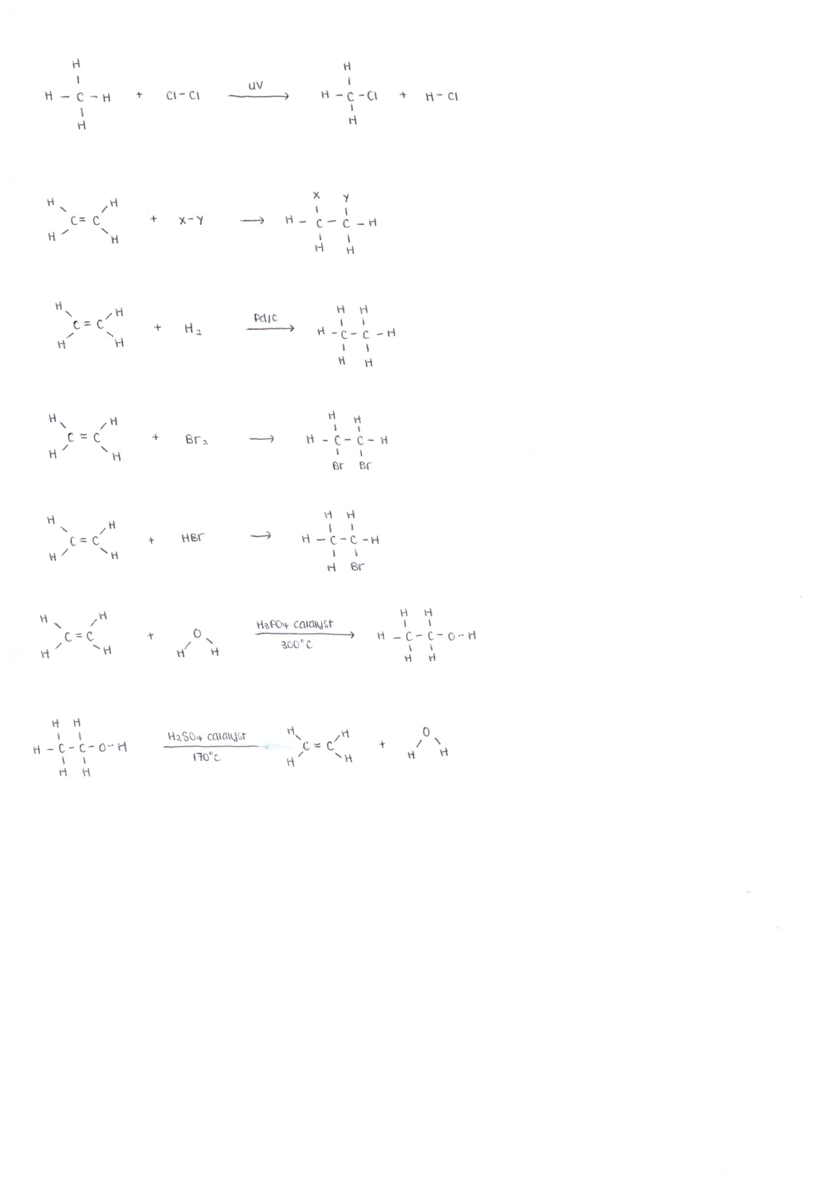Alkanes can react slowly with Cl2 and Br2 *in the presence of UV light*

**Reaction of Alkenes:**

**Combustion:**

* Complete and incomplete combustion

**Addition:**

* 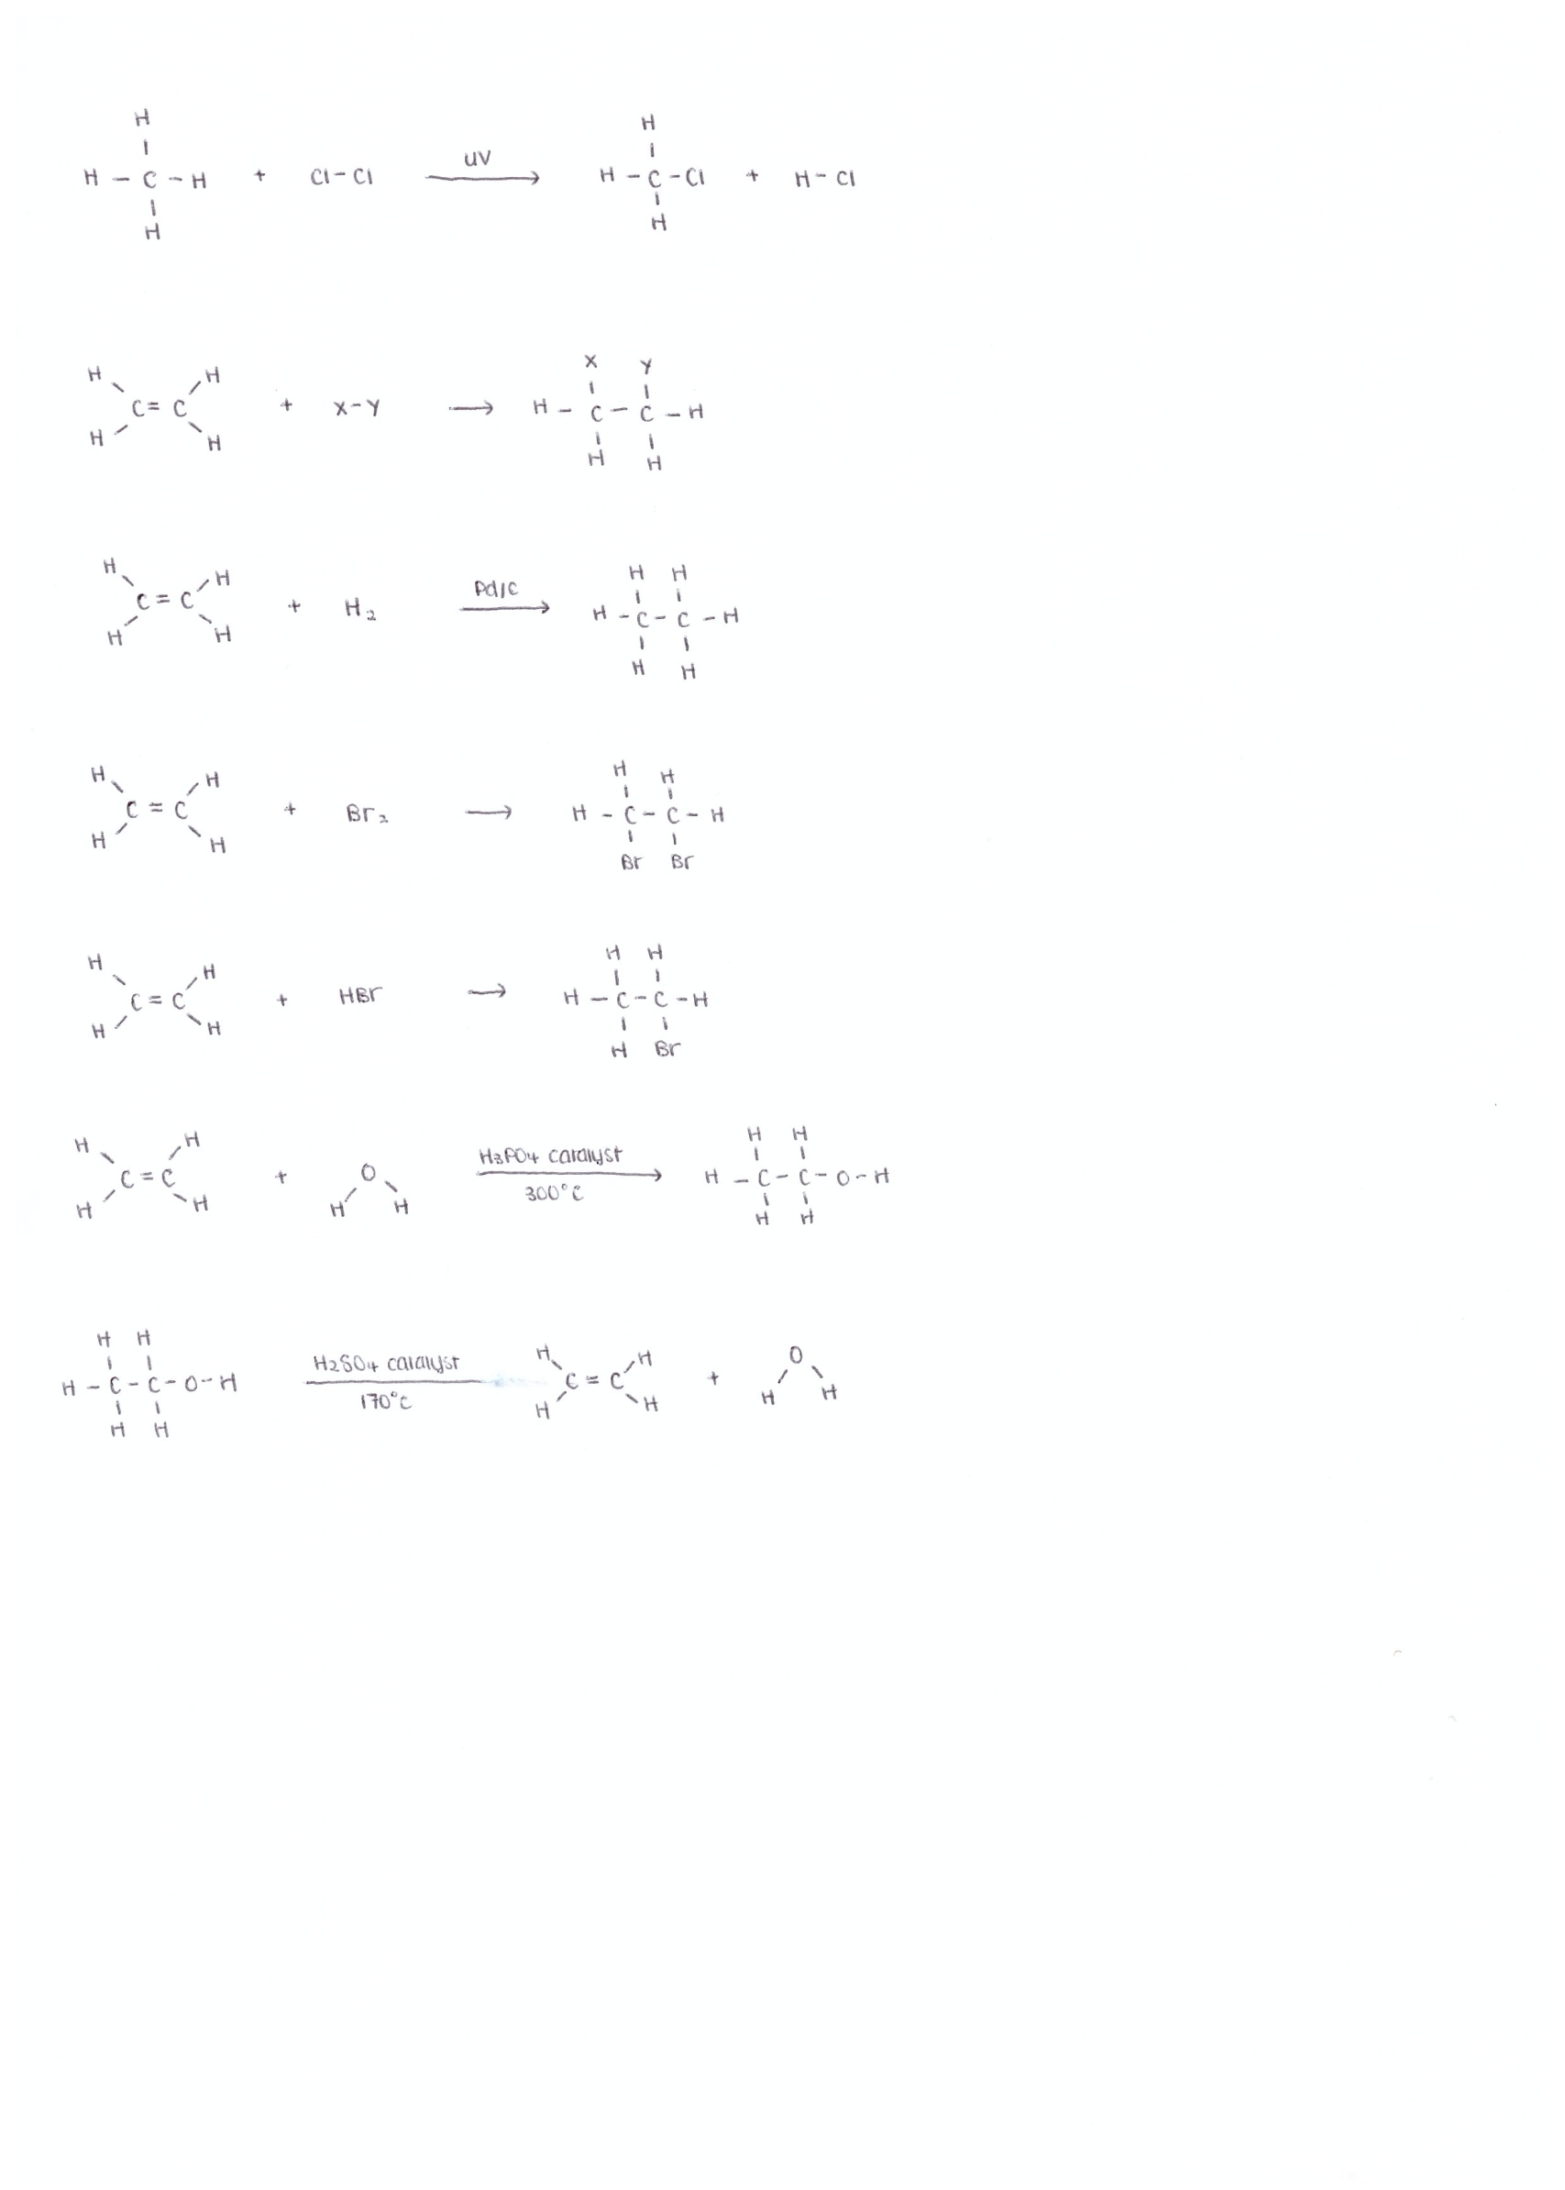Double bond is readily broken to allow atoms to add across the bond

Hydrogenation:

* Addition of *hydrogen (H2)* to an alkene in the presence of a *metal catalyst e.g. Ni, Pt, Pd/c*
* Used to *convert unsaturated to saturated fats* e.g. making margarine

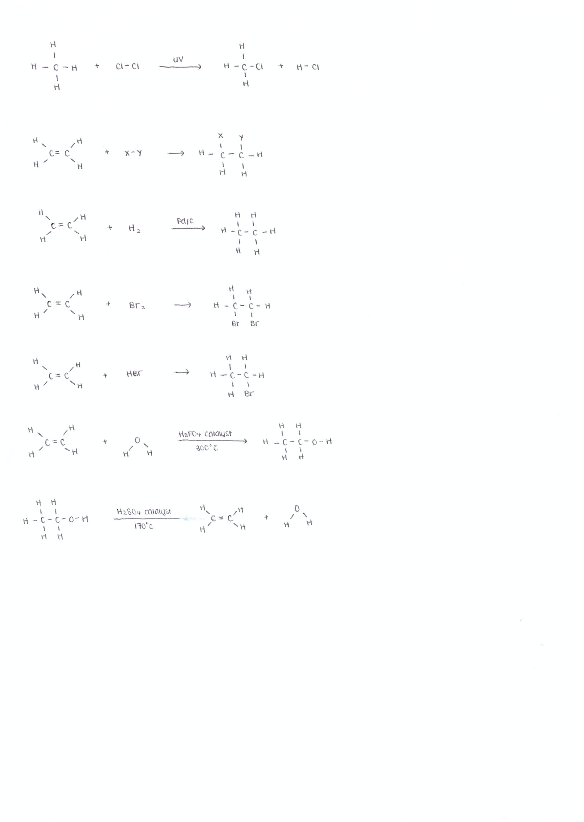

Halogenation:

* Addition of a halogen (typically Br2 and Cl2)
* 1,2-dibromoethaneis used as a *petrol additive to improve petrol performance*

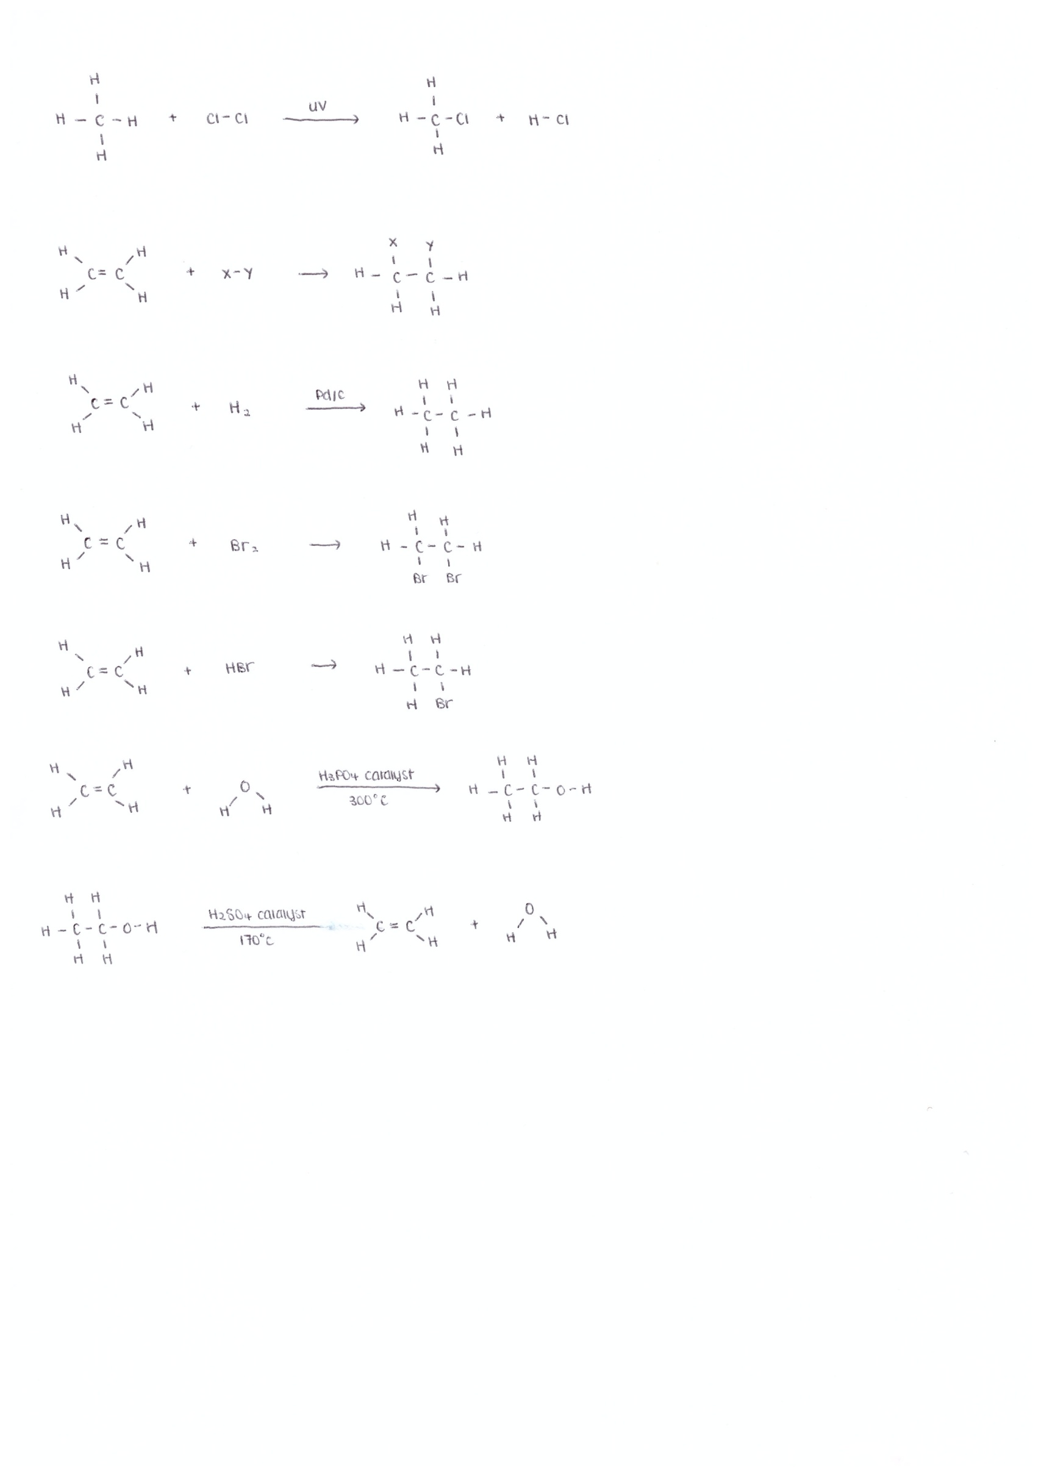

Hydrohalogenation:

* Addition of a hydrogen halide e.g. HCl, HBr
* 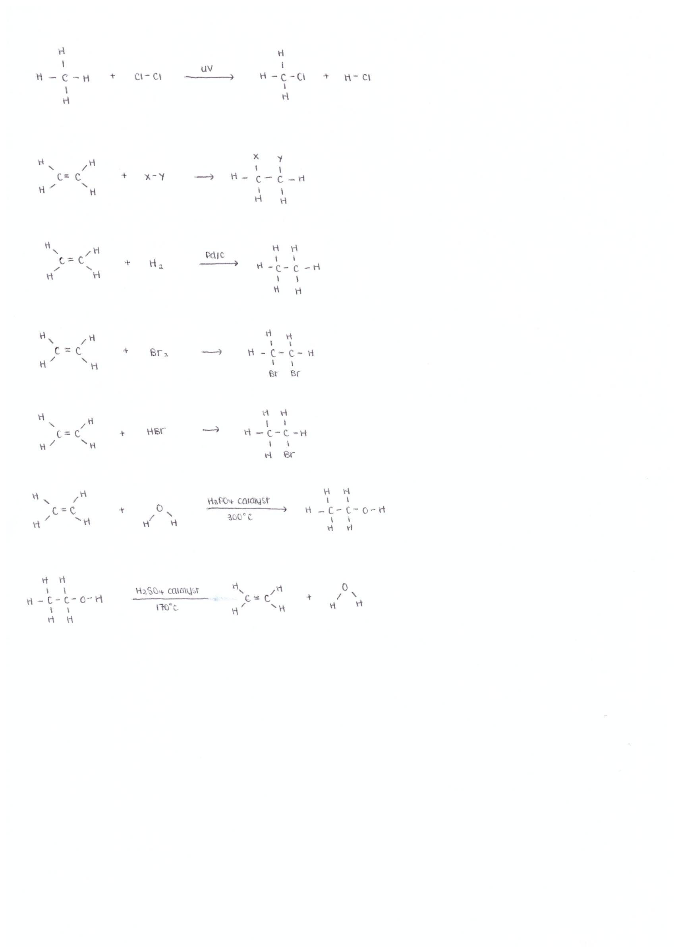Bromoethane and other haloalkanes can be used as *solvents or refrigerants*

Hydration:

* Addition of water in the presence of *dilute H+ catalyst (H3PO4 or H2SO4)* at 300°C /65atm
* Ethanol is used as a *fuel, beverage and solvent in perfumes, antiseptic, dyes*

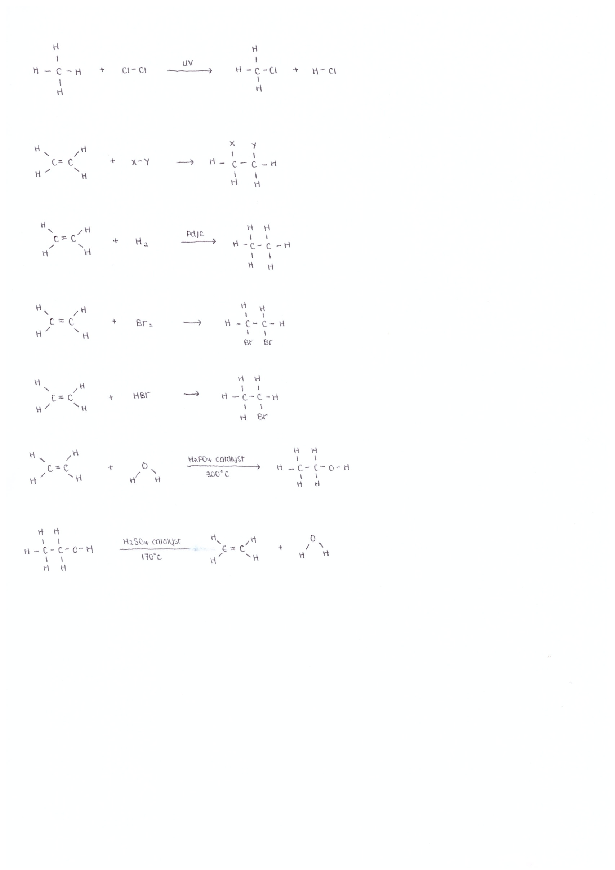

Dehydration:

* Removal of water with *concentrated H2SO4 catalyst* at about 170°C
* In industry, ethanol vapour is dehydrated with hot alumina or ceramic catalysts at 350°C

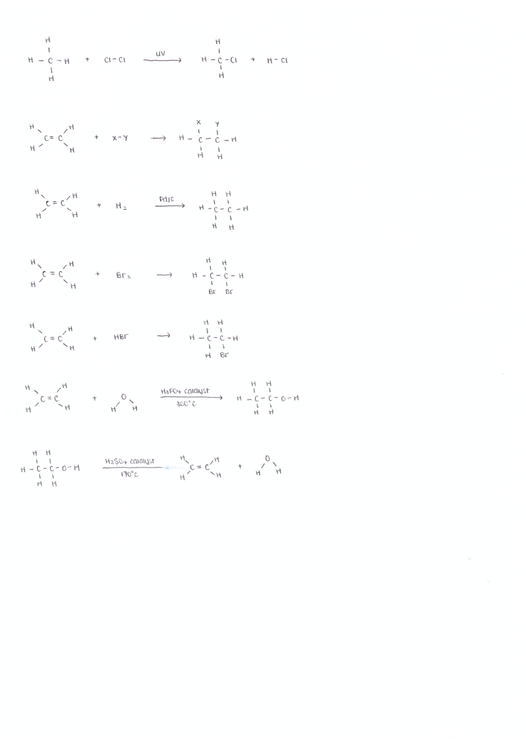

Oxidation:

* Ethylene is reacted with oxygen in the presence of a silver catalyst to form ethylene oxide. It is then treated with dilute acid solution to form ethylene glycol.
* Ethylene glycol is used in large quantities in the manufacture of polyester fibres and PET and a automotive antifreeze.

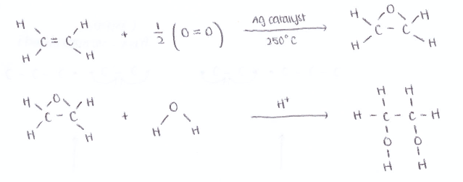

**Fossil Fuels:**

* Energy rich compounds formed by geological action on decaying plant and animal matter
* 3 major types:
  + *Coal* (decaying plant matter)
  + *Natural Gas* (methane and ethane)
  + *Crude oil/petroleum* (alkanes, some alkenes)

Crude Oil:

* Components separated by *fractional distillation*
* Volatile gases rise to the top- less dispersion forces
* *Complex mixture of hydrocarbons*
  + Linear, branched, cyclic alkanes
  + Some short chain alkenes (e.g. ethene, propene)
* Alkane fractions are used as fuels
* Alkenes are important source of petrochemical feedstock

SLT: identify the industrial source of ethylene from the cracking of some of the fractions from the refining of petroleum

**Cracking:**

* Output of petrol (gasoline) from fractional distillation is *insufficient to meets demand*
* *Cracking is used to:* 
  + *Boost the output of high demand alkanes*
  + *Produce short chain alkenes which is the basic of petrochemical feedstock (ethene)*
* Oil refineries perform cracking to *convert heavier fractions to lighter fractions* (e.g. kerosene to petrol)
* 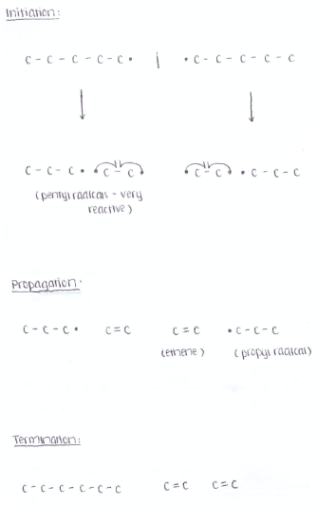High molecular weight fractions are *‘cracked’* to boost the output of high-demand low molecular weight fractions (e.g. C10H22(g) C8H18(g) + C2H4(g) )



* 2 types: Thermal/steam cracking and catalytic cracking

**Thermal Cracking:**

* Non-catalytic process- mixture of alkanes with steam is passed through very *hot metal tubes* (700 to 1000°C) with the *absence of air* and at just above atmospheric pressure to decompose the alkanes.
* Mixture of products obtained: *shorter alkanes and small alkenes*

Process:

1. Initiation: Free radicals produced when hydrocarbons are split by high temperatures
2. Propagation: Free radicals break into small radicals and produce ethene
3. Termination: Remaining free radicals react with each other to reform hydrocarbons

Disadvantages:

* *High energy requirements*, therefore expensive
* Gives *limited control* over products
  + C15H32(g) C10H22(g) + C8H10(g)



* + C15H32(g) C8H18(g) + 2C2H4(g) + C3H6(g)



* Only generally used in Australia to crack ethane or propane from natural gas
  + e.g. C2H6(g) C2H4(g) + H2(g)



**Catalytic Cracking:**

* Mixture of heavy hydrocarbons heated (to 500°C) in the presence of *zeolite crystals*

Advantages:

* *Lower temperature* therefore low energy

Zeolites:

* Crystalline aluminosilicates (Al,Si,O lattice)
* Very *porous* so high surface area for adsorbing reactants
* High thermal stability
* Can be specifically engineered to give *greater control* over products
* Non-toxic: no environmental/effects on humans

SLT: identify that ethylene, because of the high reactivity of its double bond, is readily transformed into many useful products

SLT: identify that ethylene serves as a monomer from which polymers are made

**Alkanes vs. Alkenes**

**Physical Properties:**

Similar physical properties:

* Melting and Boiling Point: Similar molecular weight and both non-polar so therefore both have same amount of intermolecular forces (dispersion forces)
* Density: Mass/volume, similar mass and similar volume
* Solubility: Both non-polar, therefore insoluble in water
* Conductivity: No free moving particle charge carriers as electrons bound tightly by strong covalent bonds

**Chemical Properties:**

Very *different* chemical properties

* Alkanes are generally *saturated and unreactive*
* Alkenes are *unsaturated* and much more *reactive* due to the presence of the C=C double bond

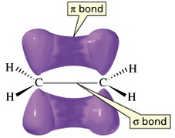The C=C Double Bond

* The C=C double bond is stronger and much more reactive.
* Stronger because you need to break the pi bond as well as the C-C single bond therefore more energy needed.
* More reactive as the C=C double bond has an additional pi bond that is more easily broken as the pi bond electrons are more exposed and have a greater chance of reacting with other substances
* *Due to the reactive double bond, alkenes can undergo addition reactions*
* *This is the basis of ethylene’s versatility for making polymers (plastics)*

**Polymers**

* High molecular weight molecules formed from simple repeating unit monomers
* 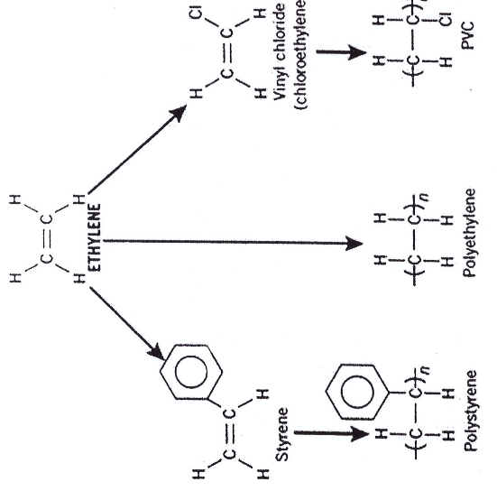Process of forming polymers is polymerisation
* 2 types: *addition and condensation*

SLT: identify polyethylene as an addition polymer and explain the meaning of this term

**Addition Polymers:**

* Polymers formed by chemically joining many monomers together *without any by-products*
* *Double bonds are broken* to allow the addition of more monomers
* E.g. polystyrene

SLT: outline the steps in production of polyethylene as an example of a commercially and industrially important polymer

SLT: identify the following as commercially significant monomers: vinyl chloride, styrene by both their systematic and common names

SLT: describe the uses of the polymers made from the above monomers in terms of their properties

**Production of LDPE- Polymerisation with an initiator**

Low density polyethylene (LDPE) is produced using an initiator. This process occurs at high temperatures (200-300 $°$ C) and high pressures (100-300 MPa). There are 3 main steps.

* Initiation (activating ethylene monomer):

A peroxide initiator (benzoyl peroxide) is decomposed (via heat) to form *peroxide free radicals.*



The free radical then *reacts with an ethylene molecule* by forcing it to “open up” its *double bond* to form a monomer radical.



* Propagation (chain reaction):

The monomer radical further reacts with ethylene molecules to form a *dimer radical*. The addition process continues in a chain reaction and the polymer radical is formed.



Branching of the polymer chain can occur if the polymer radical “back bites” on part of the existing chain. A hydrogen atom is removed so there will be an unpaired electron within the chain, rather than at the end.

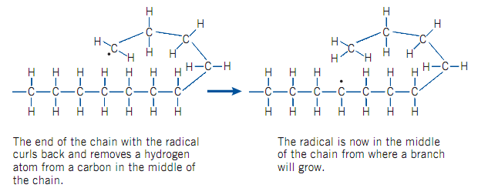

* Termination:

When 2 polymer *radicals collide and react, the chain growth terminates* and the polymer is formed.

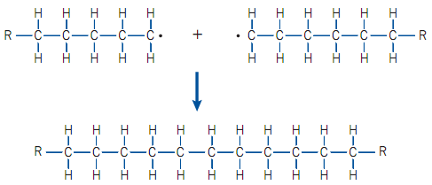

Since the termination process occurs quite *randomly*, in any polymer sample there will be a *distribution of molecular masse*s as the polymer molecules will have *different chain lengths.*

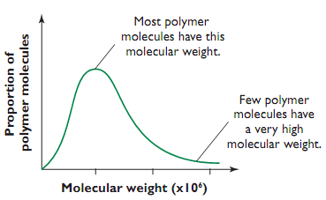ly uite rapidly ransparent

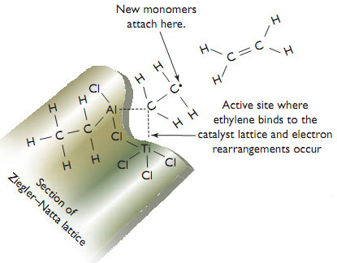

**Polymerisation of HDPE- Ziegler-Natta process**

* *High density polyethylene* (HDPE) is produced with this method
* Process occurs at *low temperatures* ($\sim$ 60 $°$ C) and *low pressures* (1 atm)
* Ethylene molecules are added to the growing polymer chain on the surface of a *Ziegler-Natta catalyst* (mixture of $TiCl_{4}$ and [triethylaluminium] $Al(CH_{2}C{H_{3})}_{3}$)
* Amount of branching is minimised, creating quite *linear unbranched chains.*
* Ethylene monomers must touch catalyst surface, adding at the catalyst surface.
* Catalysts give *greater control* over polymerisation process (terminate process by poisoning the catalyst)
* HDPE typically has about 3 times ethylene monomers than LDPE, giving it a *large molecule weight* and hence more dispersion forces.

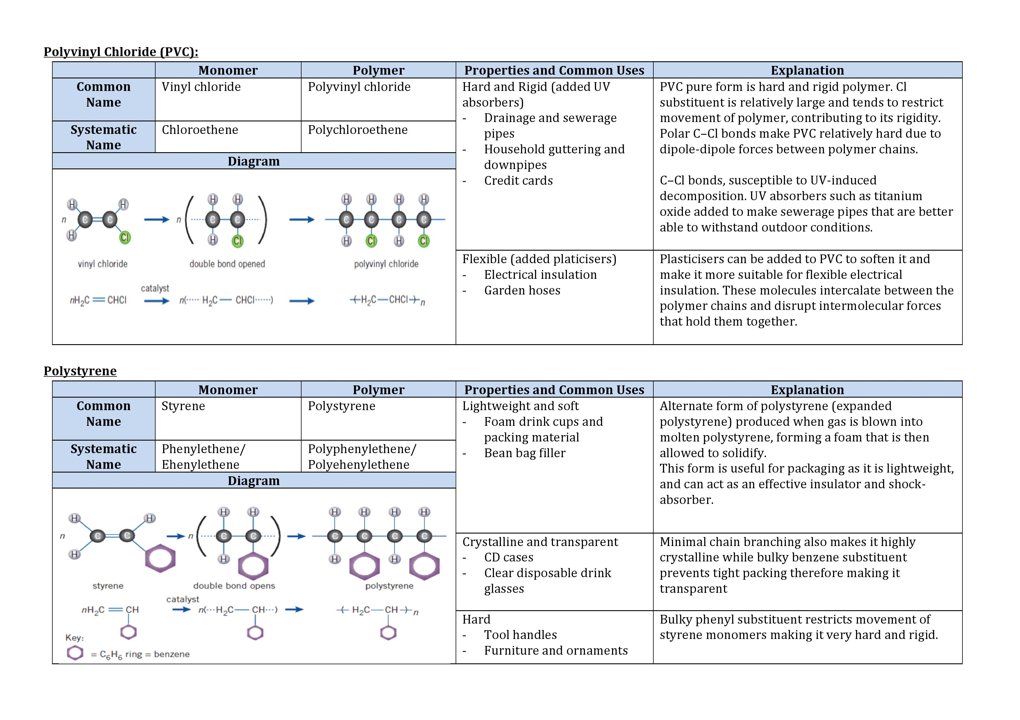

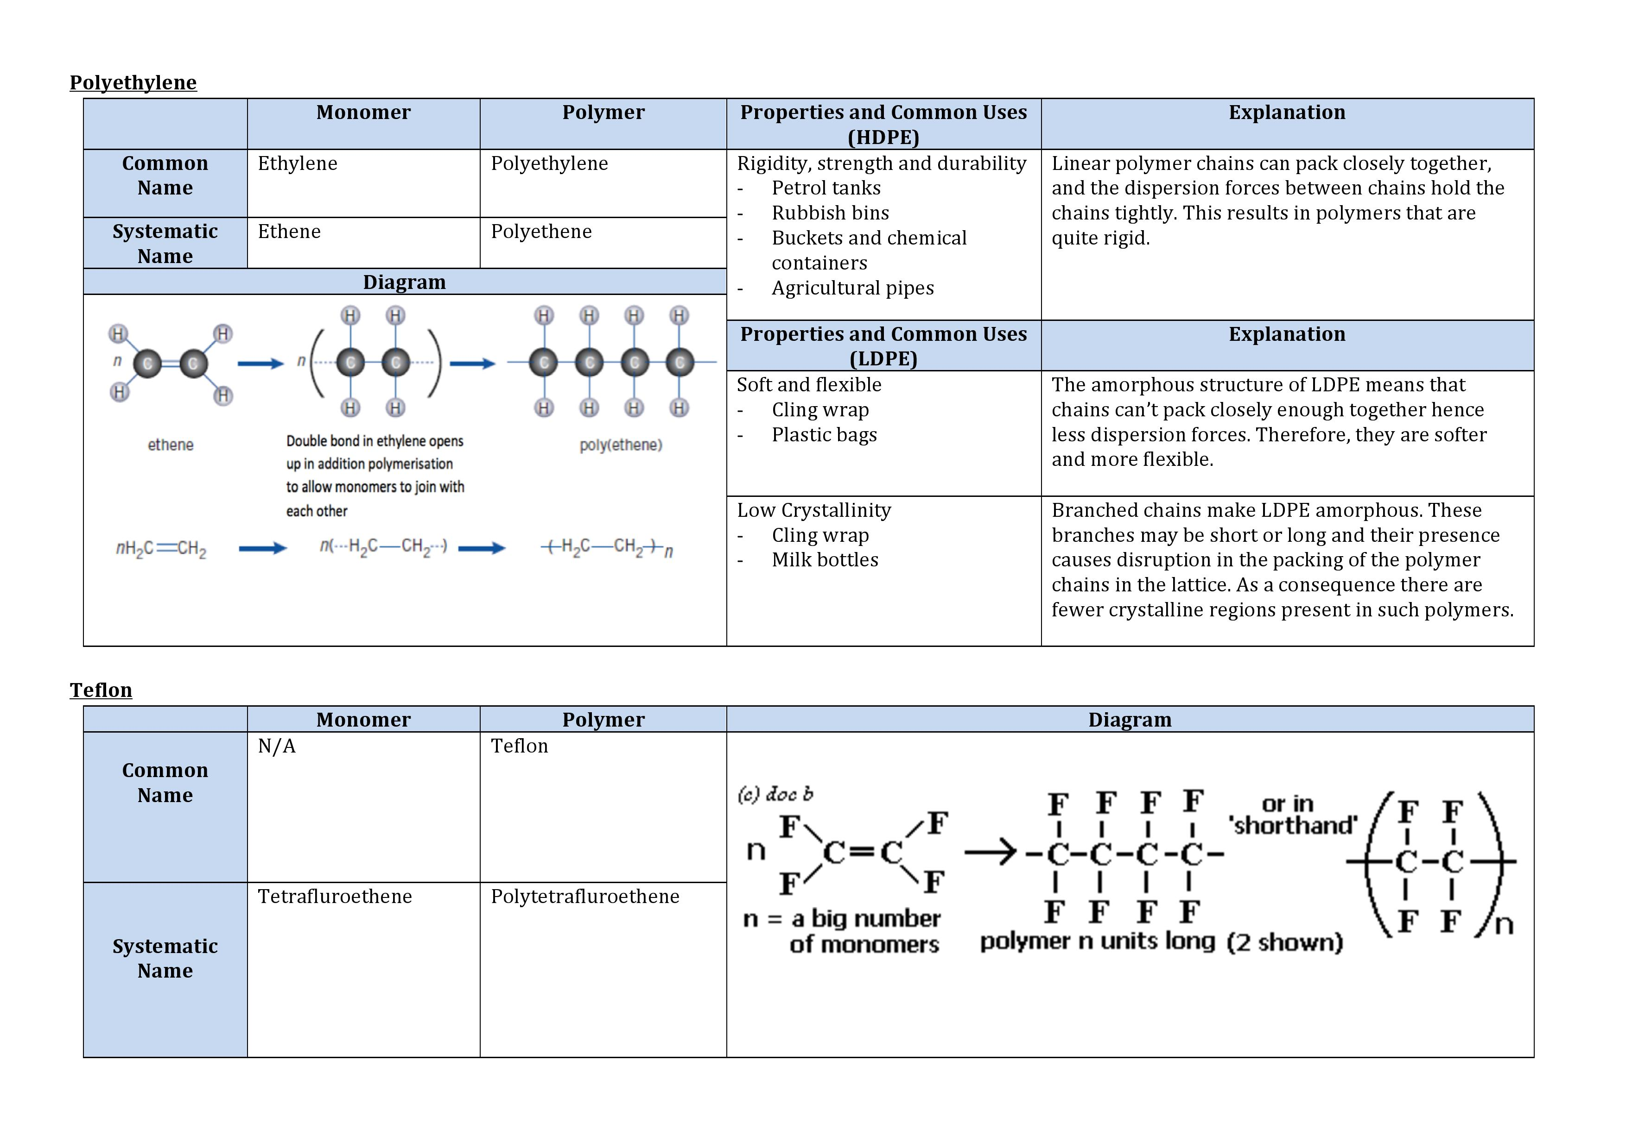

**The 5 Factors Affecting Properties and Structure**

**Average Chain Length:**

* Reflects the number of monomers in the polymer chain
* Longer polymers (high molecular weight) have *high melting points are stronger, harder and more rigid*
* The higher the molecular weight the stronger the *dispersion forces* and hence more energy is needed to break these intermolecular bonds so therefore higher melting/boiling point
* Since HDPE has a longer chain, it will have high melting points and will be stronger and harder

**Chain Branching:**

* Determines *crystallinity* of the polymer
* Opaque (crystalline): About 80–95% of HDPE consists of crystalline regions that extensively scatter and refract light, so that these polymers appear translucent or white.
* Transparent: About 40–55% of LDPE consists of crystalline regions. LDPE polymers are also more transparent because there is less scattering and refraction of light that passes through the solid.

**Substituents:**

* Monomers with heavy or bulky side substituents *restrict the movement of polymer molecules*
* Polyethylene  PVC  Polystyrene (decreasing flexibility)
* Polar substituents also *increase melting point* and *hardness* and may determine *stability*. This is because they cause dipole-dipole attractions or even H-bonds to form between monomer units.

**Cross linking**

* Involves 2 or more polymer chains covalently bonded to form an extended 2D network.
* *Increase MP, hardness and elasticity.*
* Thermoplastics (PE, PVC, PS) have no cross links, soften when heated and are easily reshaped and remoulded to make bottles, pipes etc.
* Thermosetting plastics contain many cross links and the plastic decomposes when heated. Brittle
* Elastomers (middle of thermoplastic and thermosetting) – has some crosslinking, stretch with applied force but can revert back to original shape when force is removed.

**Additives:**

Additives are used as:

* Pigments/dyes for colour
* *Plasticisers* to *soften* the polymer (phthalates are used in PVC to disrupt its dispersion forces). Pure PVC is usually never used as it is very hard and brittle due to its polar C-Cl bond.
* *Stabilisers* to prevent UV or heat decomposition (usually for PVC as C-Cl bond is vulnerable to UV attack, creating fumes when decomposed).
* *Blowing inert gases* through liquid polystyrene to make styrofoam which is good for packaging and absorbing shock

P: identify data, plan and perform a first-hand investigation to compare the reactivities of appropriate alkenes with the corresponding alkanes in bromine water

**Practical 1: Comparing Reactivities of Alkanes and Alkenes**

**Aim:** To compare the reactivity of alkanes and its corresponding alkene in bromine water

**Risk Assessment:**

* Cyclohexane and cyclohexene are highly flammable so therefore, they should not be placed near a flame
* Bromine water is volatile releases toxic fumes so therefore, this experiment should be conducted in a fume cupboard to prevent inhalation of bromine gas which could enter our system and cause poisoning
* Bromine water is corrosive so contact with skin should be avoided by using droppers and spills should be cleaned up immediately

**Apparatus:**

* 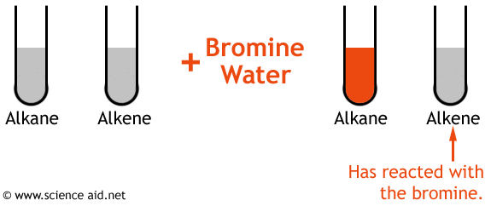1mL of cyclohexane
* 1mL of cyclohexene
* Bromine water
* Dropper
* 2 test tubes
* Test tube rack

**Method:**

* All sources of light were blocked out in the room
* Two test tubes were placed in a test tube rack which was placed into a fume cupboard
* 1mL of cyclohexane and cyclohexene were placed into separate test tubes using a dropper
* Equal volumes of bromine water was added to each test tube and shaken
* Observations were recorded
* This experiment was repeated three times

**Results:**

Only the cyclohexene was able to decolourise the bromine water

**Analysis:**

Bromine reacts readily with cyclohexene due to the presence of a *double bond.* This procedure was used because it highlighted the difference in chemical properties of cyclohexane and cyclohexene. Only the cyclohexene was able to react readily with bromine because of its double bond which *readily accepts the bromine ion*. This is unlike cyclohexane which is *saturated* and won’t react with bromine unless UV light is present.

$C_{6}{H_{12}}_{(l)}+{{Br}_{2}}_{(aq)}$

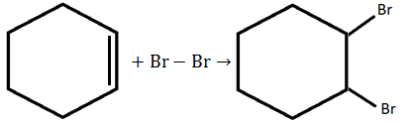

Note: Benzene does NOT decolourise bromine water even though it is unsaturated as its structure gives it great chemical stability.

**Discussion:**

Reliability:

This experiment was reliable as each time the experiment was repeated, consistent results were achieved

Accuracy:

This experiment was accurate as the process to determine the alkene and alkane were correct as this procedure was recorded in many reliable websites and textbooks.

Validity:

The experiment was valid due to the variables that have been controlled. To further improve the validity of the experiment:

* A third test tube with only bromine water in it should have been set up and used as a control.
* Aside: UV light could have affected the results. Although this experiment was conducted in the dark, it is impossible to obtain complete darkness. So UV light will always be present but in minimal amount. UV light affects the bromine water and cyclohexane by causing a substitution reaction between them so therefore results need to be recorded after a short period of time.

Variables:

Dependent: Colour of the final solution in the test tube

Independent: Hydrocarbon added to bromine water

Controlled: Blocking out sources of light (alkanes don’t react in the absence of UV light, with UV light they form free radicals), quantities, temperature and degree and period of agitation.

**Conclusion:**

Cyclohexene is more reactive than cyclohexane when reacted with bromine water. If this experiment was to be done again a third test tube with only bromine water in it should have been set up and used as a control.

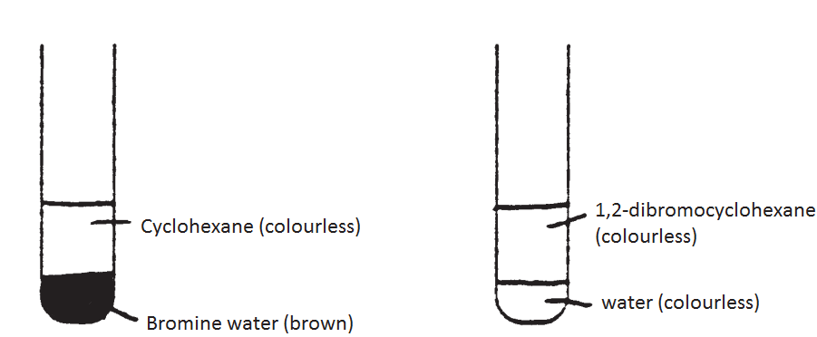

**Dot Point 2:** Some scientists research extractions of materials from biomass to reduce our dependence on fossil fuels

SLT: discuss the need for alternative sources of the compounds presently obtained from the petrochemical industry

Most synthetic polymers and fuels produced today are currently derived from crude oil which is a *non-renewable* fossil fuels, because they are economical and convenient, but:

* *World reserves of crude oil are dwindling*
* *Non-renewable, unsustainable resources* (fossil fuels formed over millions of years)
* *Increasing rates of consumption* (industrialisation, increasing populations)
* *Rising costs* (increased demand, decreased supply)
* *Substantial environmental issues*

The alternative source of compounds must be *renewable, sustainable and abundant* therefore *biomass* and *biopolymers* are ideal.

|  |  |
| --- | --- |
| **Points For** | **Points Against** |
| World’s crude oil supplies are expected to last another 50 – 100 years after which they will run out. Crude oil is also a fossil fuel, and thus they are non-  renewable. | Alternative sources such as biomass may be used however they are more expensive than crude oil to use as a source in production of materials |
| Particular petrochemical products such as petrol lead to the formation of pollutants such as CO (through incomplete combustion) which have negative impacts on the respiratory health of the population. | New infrastructure needs to be constructed (such as fermentation plants for ethanol), a process which takes time and money. |
| If crude oil runs out before alternative sources are developed then there will be less plastics, food will be more expensive, conflict and countries dependent on crude oil may possibly collapse. |  |

SLT: explain what is meant by a condensation polymer

SLT: describe the reaction involved when a condensation polymer is formed

**Cellulose:**

Condensation Polymer:

* *Condensation polymers* are polymers formed by the *elimination of a small molecule* (often water) when pairs of monomers molecules join together.
* Many *natural polymers* are condensation polymers (e.g. cellulose, starch, wool, silk, hair).
* 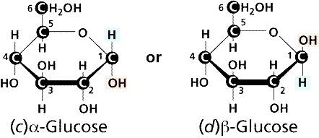Syntheticpolymers also include: polyester, nylon, PET
* *Cellulose* is a natural condensation polymer with $β$*-glucose* as its monomer
* *Biomass* - carbon based material produced by living organisms, mainly plants (e.g. crops, manure, sewage, industrial/ plant/ animal residue)

α glucose

Β glucose

SLT: describe the structure of cellulose and identify it as an example of a condensation polymer found as a major component of biomass

**The Polymerisation Process**

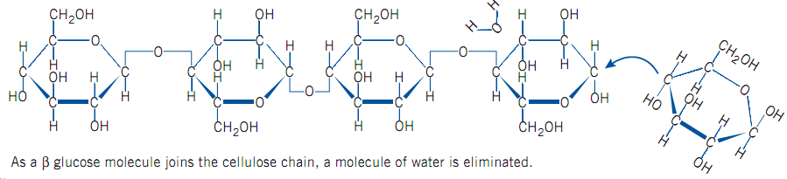

*Note: If “ $x$” monomers of $β$-glucose are condensed to form a cellulose polymer, then “ $x-1$” water molecules are eliminated*

* Cellulose is the main constituent of plant cell walls and this is a *major component of biomass*.
* Cellulose forms very *linear polymer chains*, due to its long, complex structure, it is *hard to separate*. *Hydrogen bonds* makes it *insoluble* (like dissolves like)

SLT: identify that cellulose contains the basic carbon-chain structures needed to build petrochemicals and discuss its potential as a raw material

*Cellulose* is a major component of biomass and has potential to be used as a raw material because:

* Contains the *basic carbon-chain structure* needed to build petrochemicals
* *Renewable* and *abundant*.
* *Reduces dependency* on limited fossil fuels.

In theory, cellulose can be broken down to ethylene, which can then be used to make polymers.

* *Cellulose can be used in a modified form:*
* Cellulose nitrate or cellulose acetate
* Rayon
* *Cellulose can be broken down to glucose*
* Digestion with NaOH (weakens H-bonds) and cellulose enzymes (chops into glucose units)
* Acid hydrolysis (with heating) splits H2O molecule into H and OH and reattaches onto glucose
* *Cellulose products tend to be biodegradable*

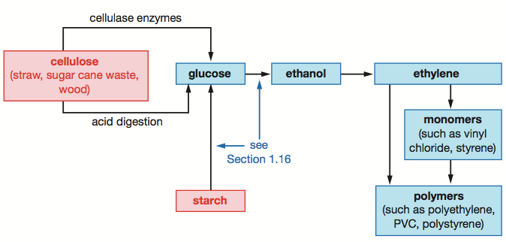

*Cellulase enzymes*

*Fermentation*

*Dehydration*

*Enzyme (amylase)*

*Polymerisation*

*Acid digestion*

Because of this, cellulose has great potential in replacing crude oil as a source of polymers. However, there are *many problems* with its use:

* Using cellulose to make petrochemicals is *expensive* and *energy intensive:*
* Significant energy is required to break cellulose down into glucose due to the *strong H-bonds between linear chains of cellulose, strong covalent bonds*
* Energy is needed to run *machinery* that are used to produce crops
* Energy is required to produce *fertilisers* for the crops
* *Planting, harvesting, transporting and processing* of cellulose are all processes which requires significant *crude oil* use; much *greater* than deriving petrochemicals from crude oil directly
* *Fertile land* is required to grow dedicated crops. This reduces food crop production (may cause food prices to rise) and can also lead to *land degradation.*
* Biomass can be *difficult to transport*and *store* (usually in solid form rather than liquid)

P: use available evidence to gather and present data from secondary sources and analyse progress in the recent development and use of a named biopolymer. This analysis should name the specific enzyme(s) used or organism used to synthesise the material and an evaluation of the use or potential use of the polymer produced related to its properties

**Biopol**

* *Biopolymer* - a naturally occurring polymer produced totally or in large part by *living organisms.*
* Are renewable, biodegradable
* *Polyhydroxyalkanoates (PHA)-* natural polyester polymers produced by certain bacteria as an energy storage material

**What is Biopol?**

*Biopol* (PHBV) is a co-polymer of PHB and PHV produced by bacteria called *Alcaligenes Eutrophus* (*a.k.a Ralstonia Eutrophus, Cupriavidus necator)*

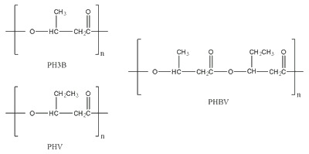

**Production:**

* A culture of Alcaligenes Eutrophus is placed in a suitable medium and fed with an appropriate *carbon based food source* (glucose, fructose) so that *bacterial growth and proliferation is promoted.*
* Certain nutrients in “diet” are then restricted; typically *nitrogen is depleted* and the bacteria *stops dividing.*
* Under these conditions, the bacteria will produce *PHBV* in cytoplasmic granules (*30-80% dry weight*), which are stored for later use as an energy source.
* The bacterial cells are then *lysed* and the polymer is *extracted and purified.*

**Properties:**

* Similar to polypropylene
* Fully *biodegradable* - breaks down into carbon dioxide and water when it is exposed to micro-organisms found naturally in soil, sewerage, river bottoms and other similar environments
* *Renewable*
* *Biocompatible* (little chance of being rejected by body)

**Potential Uses:**

* Biopol has similar properties to common synthetic plastics; *thermoplastic*, *elastomeric*, *insoluble to water*, *strong* and *resistant to chemical attack*.
* Since biodegradable, can be used as *disposable nappies, shampoo bottles, wrapping film* and *plastic bags.*
* *Biocompatible*and thus has no adverse effects when in contact with a human body*used in stents*, *sutures*, *bone plates* and *scaffolds*.

**Recent Advances:**

* Research to *genetically modify plants* to produce PHAs. By inserting bacterial genes into plants such as sugar cane, corn and potatoes to produce polymer instead of starch
* *Gene splicing* (means of transferring the PHA production capability to the *E.coli bacteria* for faster growth, higher yields and easier recovery). Advantageous because:
* Better yield of the product
* Faster growth
* Easier extraction
* Reduced production of waste biomass
* It also meant that the bacteria can be extracted from more cost effective sources. This is mainly from whey,  molasses and common agricultural wastes. This would in effect lower the commercial cost biopol.

Aside: Significance of research

The first biopol produced in industry was significantly brittle limiting usage in common disposable materials and medicine. However, a discovery of introducing propanoic acid into diet of the bacteria would produce a more flexible polymer.

**Evaluation:**

Advantages:

* *Renewable* raw material
* *Biodegradable* -better waste management, reduction of landfill and reduction of hazards to birds and aquatic organisms
* *Biocompatible*
* Only takes 2 years to decompose back into original components

Disadvantages:

* Production of Biopol is much more *expensive* than that of petrochemical plastics,
* Requires *technical expertise*
* Only *modest yields*
* *Unforeseen consequences of genetic engineering*

**Dot Point 3:** Other resources, such as ethanol, are readily available from renewable sources such as plants

SLT: describe the dehydration of ethanol to ethylene and identify the need for a catalyst in this process and the catalyst used

SLT: describe the addition of water to ethylene resulting in the production of ethanol and identify the need for a catalyst in this process and the catalyst used

**Dehydration of Ethanol**

* *Ethanol*can be *dehydrated* in the presence of *concentrated acid*at *high temperatures* to form *ethylene* and water.
$$C_{2}H_{5}{OH}_{(g)}\underset{→}{98\% H_{2}SO_{4}} C_{2}{H_{4}}_{(g)}+ H_{2}O_{(g)}$$

* The concentrated phosphoric/sulfuric acid acts as a *catalyst* and a *dehydrating agent* that removes water from the ethanol molecule.
* Conversely, *ethylene*can be *hydrated* in the presence of *dilute acid*to form *ethanol.*

$${ C_{2}{H_{4}}_{(g)}+ H_{2}O_{(g)}\underset{→}{dilute{ H}_{2}SO_{4}}C}_{2}H_{5}{OH}_{(g)}$$

* The dilute phosphoric/sulfuric acid is used as a catalyst since water itself will not ‘attack’ the electrons in the ethylene double bond.
* The reaction is done at *moderately high temperatures $(300℃)$* as a compromise between yield and rate and *high pressures* to further increase the rate of reaction and yield.

SLT: describe and account for the many uses of ethanol as a solvent for polar and non-polar substances

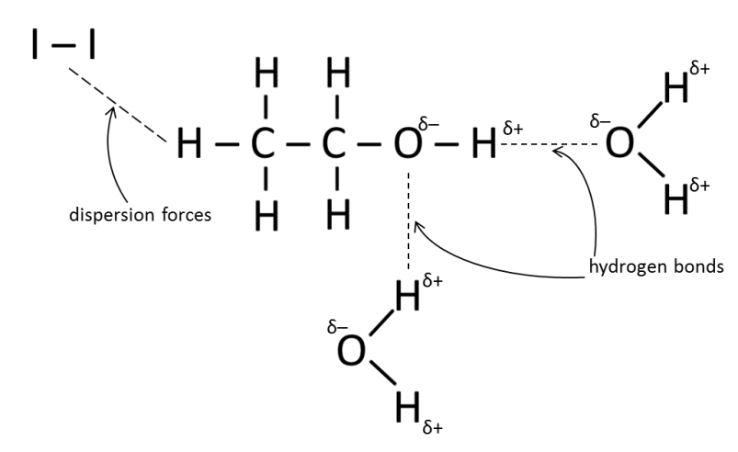**Ethanol as a Solvent**

* Ethanol is a versatile solvent used in a wide range of applications:
* Cosmetics, perfumes and deodorants
* Dyes, food colouring
* Pharmaceuticals (e.g. antiseptics)
* Varnishes, paints, resins
* *Ethanol* can dissolve both polar and non-polar substances since it is *amphipathic*
  + *Amphipathic* ***–*** when a molecule has both a polar and a non-polar end.
  + The *polar (–OH) group* in ethanol is *hydrophilic*allows it to *dissolve polar substances* (eg. water and acids) via *dipole-dipole attractions*, *ion-dipole attractions* or *H-bonds*.
  + The *non-polar ethyl group (C2H5-)* in ethanol is *hydrophobic* allows it to *dissolve non-polar substances* (eg. iodine and hexane) via *dispersion forces*.

*Note:*the non-polar and polar ends are balanced, hence no end dominates over the other.

SLT: outline the use of ethanol as a fuel and explain why it can be called a renewable resource

* Ethanol can be used as a fuel as it is a liquid that readily undergoes combustion to release energy.
$$C_{2}H_{5}OH_{(l)}+{3O_{2}}_{(g)}→ 2{{CO}_{2}}_{(g)}+{{3H}_{2}O}_{(l)} , ,∆H<0$$

* It is considered to be *renewable* as it can be manufactured from carbohydrates that are produced by the process of photosynthesis by plants.

SLT: describe conditions under which fermentation of sugars is promoted

SLT: summarise the chemistry of the fermentation process

P: process information from secondary sources to summarise the processes involved in the industrial production of ethanol from sugar cane

P: present information from secondary sources by writing a balanced equation for the fermentation of glucose to ethanol

**Production of Ethanol- Fermentation:**

**What is it?**

*Fermentation*– biochemical process in which glucose is broken down to ethanol and carbon dioxide by the action of enzymes present in yeast (i.e. zymase).

**Conditions for Fermentation (mnemonic A SALT):**

* *Anaerobic conditions* so the sugars are not oxidised to water and ${CO}_{2}$ (and prevents the production of vinegar by the yeast)
* *Source of carbohydrate*
* *Alcohol-tolerant yeast*
* *Low pH levels* to kill bacteria (prevents vinegar production due to respiration)
* *Temperature $≅$ 37 $°$ C* (the yeast will denature at temperatures > 40 $°$ C)

**The Process of Fermentation:**

* The enzymes in yeast act as *biological catalysts*.
* *Yeast enzymes*break down *starches into glucose* and *disaccharides* (eg. sucrose, maltose) into *monosaccharides* (eg. fructose, glucose).
$$C_{12}{H_{22}O_{11}}_{(aq)}+H_{2}O_{(l)}\underset{→}{yeast} 2C_{6}{H_{12}O_{6}}_{(aq)}$$

* Other enzymes then convert fructose or glucose into ethanol and carbon dioxide.

$C_{6}{H_{12}O_{6}}_{(aq)}\underset{→}{yeast} {2C}_{2}H_{5}OH_{(aq)}+2C{O_{2}}_{(g)} , ,∆H<0$

* Yeast can produce up to *12-15% $\frac{V}{V}$ ethanol.* Alcohol levels above this concentration kill the yeast and so fermentation ceases.
* To obtain higher concentrations of ethanol, *distillation*/*fractional distillation*can be used or more ethanol can be *added* to the solution.

**Ethanol From Sugar Cane:**

|  |  |
| --- | --- |
| **Ethanol from Non-renewable Material** | **Ethanol from Renewable Material** |
|  |  |

P: Solve problems, plan and perform a first-hand investigation to carry out the fermentation of glucose and monitor mass changes

**Practical 2: Fermentation of Glucose**

**Aim:** To prepare ethanol by fermentation of glucose and monitor mass changes

**Risk Assessment:**

* Fermentation of glucose produces ethanol, which is extremely flammable, so therefore this experiment should be conducted away from flames

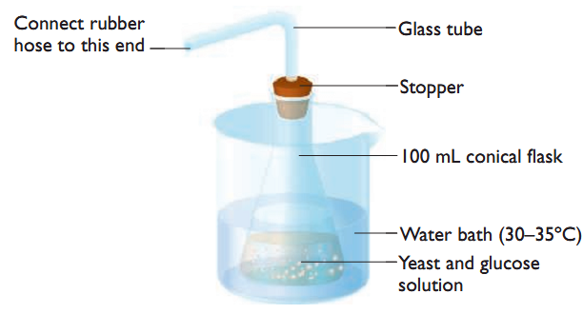**Apparatus:**

* 500ml conical flask
* 150mL water
* 15g glucose
* 5g yeast
* Stopper or cotton wool
* Bent glass tube
* Test tube with limewater
* Incubator
* Electronic balance

**Method:**

* 15 grams of glucose was weighed and placed into a 500mL conical flask
* 150mL of water was added to the flask which was shaken to dissolve the glucose
* A stopper and a bent glass tube were inserted
* The fermentation assembly was placed on a electronic balance and initial mass was recorded
* The fermentation assembly was placed in an incubator at 37°C
* After 1 day, the apparatus was taken out of the incubator, the contents of the conical flask was observed
* The fermentation assembly was weighed again, results recorded
* A test tube filled with limewater was prepared
* The end of the bent glass tube was placed into the test tube with limewater.
* Observations were recorded and apparatus placed back into the incubator
* The fermentation assembly was taken out of the incubator, reweighed daily until a constant mass was achieved

**Results:**

|  |  |
| --- | --- |
| **Day** | **Mass (g)** |
| 1 | 381.05 |
| 2 | 376.96 |
| 3 | 373.42 |
| 4 | 370.44 |
| 5 | 270.42 |
| 6 | 370.40 |
| 7 | 370.39 |

**Analysis: Calculations**

To calculate the mass of ethanol formed, assume the mass lost was entirely due to carbon dioxide.

$$m\left({CO}_{2 }lost\right)= 381.05-370.39$$

$$=10.66 g$$

$$C_{6}{H_{12}O_{6}}_{(aq)}\underset{→}{yeast} {2C}_{2}H_{5}OH_{(aq)}+2C{O_{2}}_{(g)}$$

$$n \left({CO}_{2 }\right)= \frac{10.66}{12.01+2(16)}$$

$=0.24 mol$

$$n \left(C_{2}H_{5}OH\right)= 2\left(0.24\right)$$

$$=0.48 mol$$

$∴ m \left(C_{2}H_{5}OH\right)= 0.48 (2\left(12.01\right)+ 6\left(1.008\right)+16)$

$=22.32 g$

To calculate concentration of ethanol,

$$d= \frac{m}{v}$$

$$0.789=\frac{22.32}{v (C_{2}H_{5}OH)}$$

$$v (C_{2}H_{5}OH) =28.29 mL$$

$$∴\left[C_{2}H_{5}OH\right]=\frac{ 0.48}{0.02829}$$

$$=16.97 molL^{-1}$$

$$∴\left[C_{2}H_{5}OH\right]=\frac{ 22.32}{150}×100\%$$

$$=15\% w/v$$

**or**

**Discussion:**

Reliability:

This experiment was reliable; when results were compared others, the differences in results were minimal.

Accuracy:

This experiment was accurate as the correct apparatus was used and none which were faulty.

Validity:

This experiment was valid due to an appropriate procedure being used. The incubator increased the validity as it helped achieve the temperature needed for fermentation. However, in order to further increase the validity, the following need to be considered:

* We assumed the mass loss was entirely due to carbon dioxide gas. This may be incorrect as it is possible not all the carbon dioxide escaped the conical flask.
* The fermentation assembly was placed in a warm place; the water would be prone to evaporation. Since the fermentation system isn’t closed, extra water could have evaporation, contributing to the extra mass loss.
* A suitable control for this experiment would be another conical flask under identical conditions containing only the glucose solution (no yeast). Any mass loss of the control can be used to adjust the loss in mass of the fermenting mixture.

Variables:

* Dependent Variable: Carbon dioxide gas
* Independent Variable: Yeast
* Controlled Variable: Condition of room

**Conclusion:**

22.32 g of ethanol and 10.66 g of carbon dioxide was produced via the fermentation of glucose. However, if this experiment were to be conducted again, a suitable control would be used.

SLT: define the molar heat of combustion of a compound and calculate the value for ethanol from first-hand data

**Molar Heat of Combustion**

* Amount of heat liberated when *one mole* of a substance undergoes complete combustion under standard conditions (RTP) with the final products being carbon dioxide gas and liquid water.

Where:

* = heat of combustion ($J{mol}^{-1}$)
* m = mass of substance undergoing temperature change (g)
* c = specific heat capacity ($JK^{-1}g^{-1}$)
* $∆t$ = change in temperature (K)
* n (fuel) = number of moles of the substance undergoing combustion (mol)

**Specific Heat of Combustion:**

* Amount of heat liberated when *one gram* of a substance undergoes complete combustion under standard conditions (RTP) with the final products being carbon dioxide gas and liquid water.

Where:

* = heat of combustion ($Jg^{-1}$)
* m = mass of substance undergoing temperature change (g)
* c = specific heat capacity ($JK^{-1}g^{-1}$)
* $∆t$ = change in temperature (K)
* m (fuel) = mass of the substance undergoing combustion (g)

$$∆H_{c}= \frac{-mc∆t}{m (fuel)}$$

*Note: To convert from kJg-1 to kJmol-1 and vice versa you:*

$$\frac{kJ}{g}×\frac{g}{mol}=\frac{kJ}{mol}$$

*Note: To convert from kJmol-1 to kJg-1 you:*

P: identify data sources, choose resources and perform a first-hand investigation to determine and compare heats of combustion of at least three liquid alkanols per gram and per mole

**Practical 3: Heat of Combustion**

**Aim:** To determine and compare the heats of combustion of three alkanols per gram and per mole

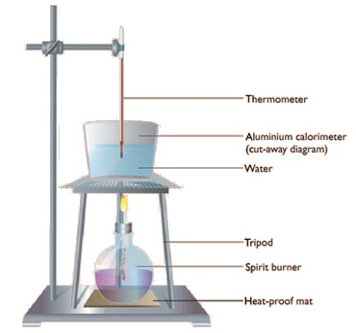

**Risk Assessment:**

* Incomplete combustion may occur which produces respiratory irritants such as soot and carbon monoxide. Therefore this experiment should be conducted in a well-ventilated area.

**Apparatus:**

* Aluminium calorimeter
* Thermometer
* Methanol, ethanol, butanol spirit burner
* Tripod and gauze mat
* Heat proof mat
* 100mL of water
* Retort stand with bosshead and clamp
* Electronic balance

**Method:**

1. An empty aluminium can was weighed using an electronic balance and mass recorded
2. The can was filled with 100mL of water
3. The aluminium can with water was weighed and mass recorded
4. The initial water temperature was measured with a thermometer and temperature recorded
5. The spirit burner containing methanol was weighed and mass recorded
6. The apparatus was set up according to the diagram
7. The aluminium can was heated with a Bunsen burner for 10 minutes
8. The final water temperature was recorded
9. The spirit burner containing methanol was reweighed and mass recorded
10. This entire process was repeated using ethanol and butanol and results recorded in a table

**Results:**

|  |  |  |  |  |  |
| --- | --- | --- | --- | --- | --- |
|  | **Initial burner mass (g)** | **Final burner mass (g)** | **Mass of water (g)** | **Initial Temperature ($℃$)** | **Final Temperature ($℃$)** |
| **Methanol** | 208.60 | 207.50 | 100 | 23 | 40 |
| **Ethanol** | 206.74 | 205.60 | 97.86 | 24.5 | 54.5 |
| **1 - butanol** | 208.30 | 207.43 | 100 | 23 | 57 |

**Analysis:**

It was found that $\left|∆H_{c} (1-butanol)\right|>\left|∆H_{c} (ethanol)\right|> \left|∆H_{c} (methanol)\right|$. Because combustion reactions are exothermic, more energy is realised when bonds form than energy supplied to break bonds. Since more bonds need to be formed in the product molecules when the alkanols with a longer carbon chain are combusted, there is more energy released.

**Analysis- Calculations:**

$$m \left(C_{2}H_{5}OH\right)= 206.74-205.6$$

$=1.14 g$

$$∆H_{c}(C_{2}H_{5}OH)= \frac{-\left(97.68\right) \left(4.18\right) (54.5-24.5)}{1.14}$$

$$= - 10764.6 Jg^{-1}$$

$$∆H_{c}\left(C_{2}H_{5}OH\right)=\left(2\left(12.01\right)+ 6\left(1.008\right)+ 16\right) g{mol}^{-1} x (-10764.6) Jg^{-1}$$

$= - 495903.59 J{mol}^{-1}$

$= - 496 kJ{mol}^{-1}$

These calculations can be repeated for methanol and 1 – butanol.

*Note: $∆H_{c} Jg^{-1} x M g{mol}^{-1}=∆H_{c} {Jmol}^{-1}$. This allows for a simple conversion between the heat released per gram and the heat released per mole.*

**Discussion:**

Reliability:

This experiment was not reliable, when the experiment was repeated; the results obtained were not consistent.

Accuracy:

This experiment was not accurate because the apparatus used results in too many errors due to heat lost to the surrounding atmosphere. To increase accuracy:

* A lid should have been placed on the calorimeter and heat shields should have been used to minimise the heat lost to the surrounding atmosphere
* A digital thermometer should have been used

Validity:

This experiment was not valid due to having too many variables affecting the experiment, which results in heat loss, and hence the calculated heat of combustion was lower than the accepted literature value. This is due to:

* The distance between the calorimeter and flame, this should be reduced
* As molecular weight increases, the more oxygen needed to achieve complete combustion. Lack of oxygen could have resulted in incomplete combustion of butanol, which has a lower heat of combustion.
* Heat from flame is also lost to heating up the aluminium calorimeter, the specific heat capacity of the calorimeter should be accounted for: $q={(mc∆t)}_{water}+(mc{∆t)}_{calorimeter}$

Variables:

Dependent: Heat of combustion

Independent: Molecular weight

Controlled: Energy supplied (heat), Bunsen burner, aluminium calorimeter

**Conclusion:**

The molar heat of combustion of methanol, ethanol and 1-butanol was measured to be $268kJ{mol}^{-1} or 8.36 kJg^{-1} , 496 kJ{mol}^{-1} or 10.8 kJg^{-1}$ and $838 kJ{mol}^{-1} or 11.3 kJg^{-1}$ respectively.

*2014 POM Exam*

*E.g.1) The molar heat of combustion of 1-propanol is 2021kJmol-1. What mass of 1-propanol must be combusted to boil 300mL of water if the water has an initial temperature of 20°C and only absorbs 75% of the heat released?*

$${ΔH}_{c}=-\frac{Q}{n} \\ 2021000(0.75)=-\frac{Q}{n} \\ Q=\left(300\right)\left(4.18\right)\left(80\right) \\ =100320$$

$$n=\frac{m}{M} \\ 0.0662=\frac{m}{3\left(12.01\right)+8\left(1.008\right)+16} \\ ∴m=3.98g$$

SLT: identify the IUPAC nomenclature for straight-chained alkanols from C1 to C8

**Naming Alkanols:**

* Alkanolsare a homologous series of compounds with the $–OH$ *(hydroxyl) functional group.*
* Their general formula is ${ C}_{n }H_{2n+1}OH$ where n > 0 and $n∈Z.$
* Rules for naming an alkanol:

1. Identify the number of carbons present in a straight chain.
2. Select the correct stem to name the parent alkane.
3. Remove the “e” and replace it with the suffix “ol”.

Note:

If n ≥ 3, number the chain from the end such that the carbon with the –OH group is given the lowest number possible. Insert the number of the carbon with the –OH group in front of the name of the alkanol.

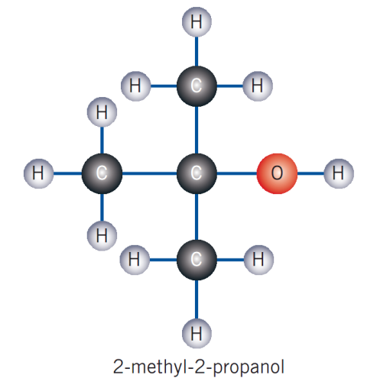

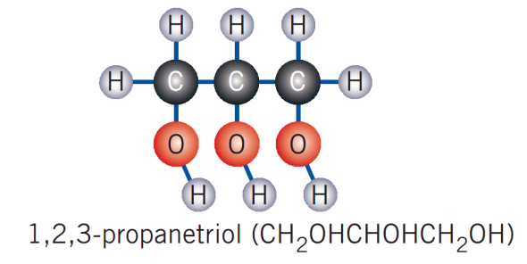

P: process information from secondary sources to summarise the use of ethanol as an alternative car fuel, evaluating the success of current usage

**Ethanol as an Alternative Car Fuel:**

**Advantages**

* Ethanol is a *renewable resource*, which reduces our reliance on fossil fuels.
* ‘*greenhouse-neutral’* since the net CO2 ethanol releases when used is 0.

Photosynthesis: $6C{O_{2}}_{(g)}+ 6H_{2}O_{(l)}→C_{6}{H_{12}O_{6}}_{(aq)}+ 6{O_{2}}_{(g)}$

Fermentation: $C_{6}{H_{12}O_{6}}_{(aq)}→ {2C}_{2}H_{5}OH_{(aq)}+2C{O_{2}}_{(g)}$

Combustion: $2C_{2}H_{5}OH_{(l)}+{6O_{2}}_{(g)}→ 4{{CO}_{2}}_{(g)}+{{6H}_{2}O}_{(l)}$

* Despite these equations, ethanol is not actually greenhouse neutral since the energy input for cultivation, *production of fertilisers, distillation and disposal of fermented waste products* comes *from the combustion of fossil fuels which all release carbon dioxide*
* But still this process *produces less carbon dioxide* overall compared to octane.
* Ethanol *burns more completely/ ‘cleanly’*than octane in air under the same conditions due to:
* Already having oxygen within it
* More likely to undergo complete combustion

The stoichiometric equations to the left shows that that ethanol is more likely to undergo complete combustion, producing fewer pollutants such as CO and soot.

Ethanol: $C_{2}H_{5}OH_{(l)}+{3O_{2}}_{(g)}→ 2{{CO}_{2}}_{(g)}+{{3H}_{2}O}_{(l)}$

Octane: ${C_{8}H_{18}}_{(l)}+ \frac{25}{2}{O_{2}}_{(g)}→8{{CO}_{2}}_{(g)}+ 9H_{2}O_{(g)}$

* Mixtures of ethanol and octane do *boost the* *octane rating* of the fuel *reduces engine knock*

**Disadvantages:**

* Requires *large areas of land* to grow suitable crops.
* Potential *land degradation* problems such as soil erosion, deforestation, fertiliser runoff and salinity.
* Land used for ethanol production cannot be used for food production 🡪may cause food prices on the market to rise.
* Need to dispose smelly fermentation waste products
* Combustion of ethanol *releases less energy* per mole than octane
* Petrol mixtures with high concentrations of ethanol (>15-20%) requires *expensive engine modifications* in order to use ethanol
* Can corrode engine pipes and lead to blockage because ethanol is a good solvent
* Using ethanol as a fuel in cold weather is more difficult because higher flash point

**Current status**

* Since producing ethanol is still more expensive than petrol
* *E10 fuel* (90% ULP, 10% ethanol) is now widely available in Australia. Car manufacturers accept that up to 10% ethanol has no detrimental effect on vehicles but they *oppose the use of higher concentrations*.
* The plans to make E10 compulsory in NSW have recently been abandoned. Thus ethanol usage in Australia has only been *partially successful*.

Aside: Status in Brazil

* Most active biofuel industry worldwide
  + Began in the 1970s to reduce reliance on oil imports and boost employment income
  + Government subsidised ethanol production form sugar cane
* This led to an unexpected boom with more than 90% of cars in mid 1980s using ethanol
* But in the 1990s, a crisis ensued
  + Severe ethanol shortage and dropping world oil prices
  + Inflationary pressures on food
  + Loss of government support
* Industry only recently been revitalised
  + Flex-fuel cars introduced in 2003 and rising oil prices
  + Ongoing research and government investment

**Evaluation**

Ethanol has *great potential* to be used as a renewable alternative fuel, however, its use is currently limited due to its cost.

**Dot Point 4:** Oxidation-reduction reactions are increasing important as a source of energy

SLT: explain the displacement of metals from solution in terms of transfer of electrons

SLT: identify the relationship between displacement of metal ions in solution by other metals to the relative activity of metals

**Metal Displacement Reactions**

* *Metal displacement reaction*is an *electron transfer/redox reaction* in which an active metal reacts with a solution containing the ions of a different metal.

Consider Zn being placed in $Cu^{2+}$ solution:

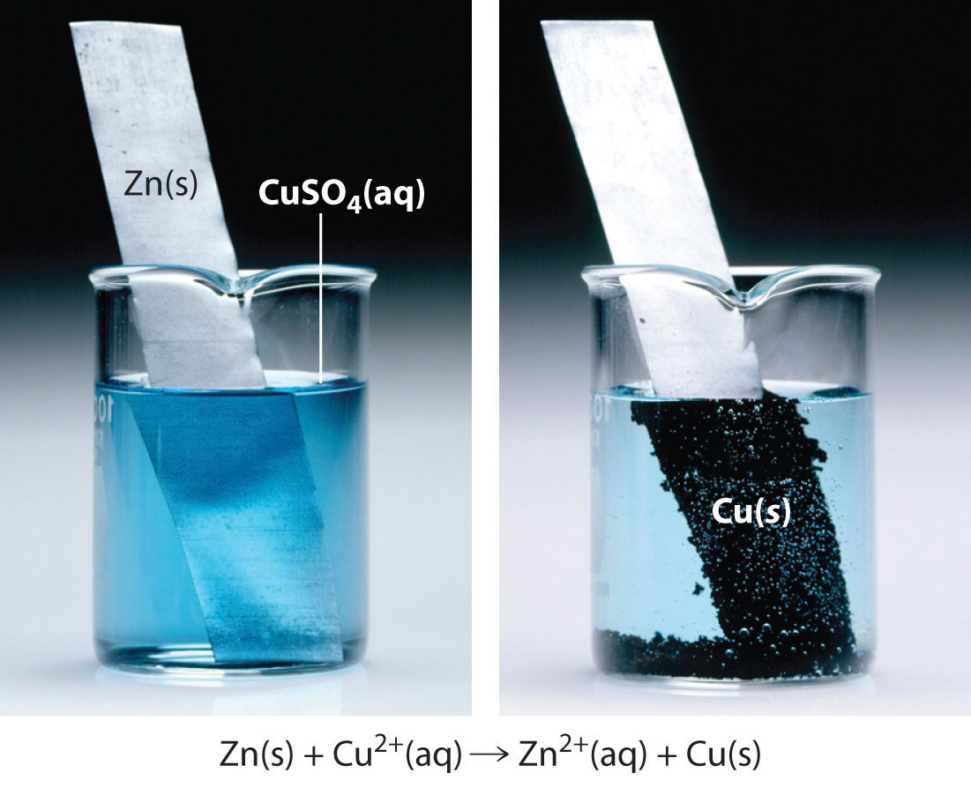

${ Zn}_{(s)}→ {{Zn}^{2+}}_{(aq)}+ 2e^{-}$*oxidation* half equation – *loss of electrons*

${{Cu}^{2+}}_{(aq)}+ 2e^{-} → {Cu}_{(s)}$*reduction*half equation – *gain in electrons*

${Zn}_{(s)}+{{Cu}^{2+}}_{(aq)}→{{Zn}^{2+}}_{(aq)}{ + Cu}_{(s)}$ (*net ionic equation*)

*In Summary:*

* *More reactive metals are readily OXIDISED = stronger REDUCTANTS*
* *In general, a more reactive metal will displace the ions of a less reactive metal from solution.*

SLT: account for changes in the oxidation state of species in terms of their loss or gain of electrons

**Oxidation States:**

* *Oxidation state/oxidation number* - a number or charge assigned to an atom based on a set of rules. It indicates the number of e- lost or gained and the degree of oxidation.
* To give oxidation number, *assume atom/compound is ionic.*
* *In general, hydrogen in compounds has an oxidation state of +1 and oxygen in compounds has an oxidation state of -2*

There are 4 rules when assigning oxidation states:

1. *Atoms in their elemental state:*

Oxidation number = $0$. (e.g. Na, Cl2)

1. *Monatomic ions*:

. (e.g. Cl- = -1, Ca+2 = +2)

1. *Polyatomic ions*:

(e.g. NO3-: Nitrogen 🡪+5, Oxygen🡪-2, SO42-)

1. *Neutral compound*:

(e.g. CO2)

* Oxidation states help us identify redox reactions and track the transfer of electrons.
* *Increase in oxidation state = oxidation (becomes more positive = loss of electrons)*
* *Decrease in oxidation state = reduction (becomes more negative = gain of electrons)*
* Note: oxidation number is usually an *integer* but sometimes can be a *fraction* because it represents the *average oxidation state* of an element in a species.

E.g.1

Note: corresponding colours represent redox couples

${Zn}_{(s)} +{{ Cu}^{2+}}_{(aq)} → {{ Zn}^{2+}}_{(aq)}{ + Cu}_{(s)}$

Oxidation Number: 0 +2 +2 0

* Zinc is oxidised because of increase in oxidation number

E.g.2

2I-(aq) + H2SO4(l) + 2H+(aq) I2(aq) + SO2(g) + 2H2O(l)

Oxidation Number: -1 +1 +6 -2 +1 0 +4 -2 +1 -2

* Sulfuric acid is reduced to sulfur dioxide

HSC 2010:

*E.g.1) An aluminium rod was placed in a 50.0mL of silver nitrate solution. After a period of time, the concentration of aluminium ions in the solution was determined to be 0.120molL-1. What mass of solid was formed during this time period?*

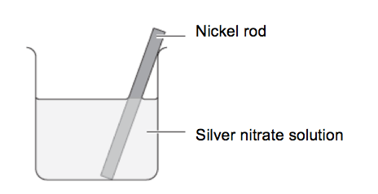

Aluminium rod

Silver nitrate solution

$$c=\frac{n}{v} \\ 0.12=\frac{n}{0.050} \\ n=0.006 \\ n=\frac{m}{M} \\ 0.018=\frac{m}{107.9}$$ $∴m=1.94$ g

Al(s) + 3AgNO3 Al(NO3)3 + 3Ag

0.006mol 0.018mol

Al(NO3)3  Al+ + 3(NO3-)

0.006mol 0.006mol 0.018mol

SLT: outline the construction of galvanic cells and trace the direction of electron flow

SLT: define the terms anode, cathode, electrode and electrolyte to describe galvanic cells

**Redox Reactions:**

**Definitions:**

Anode: the electrode at which oxidation occurs. (ANOX)

Cathode: the electrode at which reduction occurs. (REDCAT)

Electrode: the conductors of a cell which gets connected to an external circuit (e.g. conductive metal or graphite plate)

Electrolyte: a substance that conducts electricity when aqueous or molten (i.e. releases ions when in solution or melted)

Anolyte: electrolyte in anode compartment

Catholyte: electrolyte in cathode compartment

**Galvanic Cells:**

* A galvanic cell consists of 2 separated half cells with *an electrode immersed in an electrolyte.*
* Oxidation (loss or electrons) occurs in one cell, reduction (gain of electrons) occurs in other cell.
* Below, zinc is a *reductant*, copper is an *oxidant.*

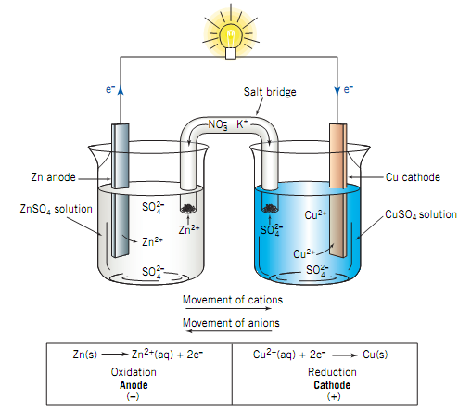

*Internal circuit:*

*– charge is carried by ions*

*Anions move to $→$ anode*

*Cations move to $→$ cathode*

*Note:*

*External circuit:*

*– charge is carried by electrons*

**Salt Bridge:**

* A *salt bridge* is required in a galvanic cell because
* It *completes the circuit*
* Allows for *ion migration* to *maintain electrical neutrality*
* The salt bridge is usually filter paper saturated with an *electrolyte solution* (usually). KNO3 is used as it will not react with ions to produce precipitates.
* Salt bridges can be a: U-tube with electrolyte in agar jelly and plugged with cotton wool or porous partition.

**Cell Notations**

* The*cell notation* for the galvanic cell above is:
$${Zn}_{(s)}| Zn{SO_{4}}_{\left(aq\right)} || Cu{SO_{4}}_{\left(aq\right)}|{ Cu}_{(s)}$$

* If a *redox couple* involves only gaseous or ionic species then an *inert electrode*such as Platinum (Pt) or a graphite rod can be used.

E.g.

${Zn}_{(s)}| {{Zn}^{+2}}_{\left(aq\right)}|| {Fe}_{\left(aq\right)}^{+2},{Fe}_{\left(aq\right)}^{+3} |{Pt}_{\left(s\right)}$

*Oxidation*: ${Zn}_{\left(s\right)}→ {{Zn}^{2+}}_{\left(aq\right)}+ 2e^{-}$

*Reduction*: ${{Fe}^{3+}}_{(aq)}+ e^{-} → {{Fe}^{2+}}_{(aq)}$

P: solve problems and analyse information to calculate the cell potential requirement using tables of standard potentials and half-equations

**Cell Potentials:**

* These are measured at*25 $°$ C, gas pressure at 100 $kPa$*and with*1 $mo{lL}^{-1}$ electrolyte solutions.*
$${}_{cell}={}_{reduction}+{}_{oxidation}$$

* Standard reduction potentials can also be used to predict whether a redox reaction will occur or not. Redox reactions have the potential to occur only if ${}_{cell}>0.$
* $∴{}_{cell}<0$ means reaction is *not spontaneous*

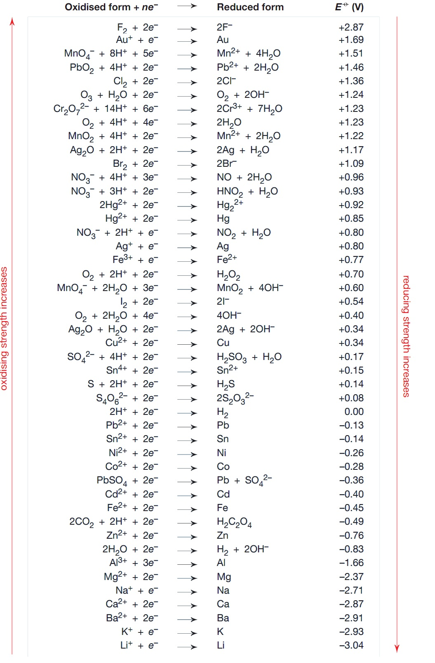

**Strongest oxidants Most easily reduced**.

**Strongest reductants Most easily oxidised**

*HSC 2011:*

*Calculate the standard cell potential of the following galvanic cell. Include a net ionic equation in your answer.*

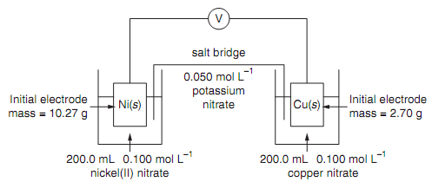

Solution:

Step 1: Determine which beaker contains the anode and the cathode by using the table of standard reductions. The beaker containing the substance that is higher in the table will contain the anode while the beaker containing the substance that is lower in the table contains the cathode.

* The beaker on the right contains the anode while the beaker on the left contains the anode.

Step 2: Write down the oxidation and reduction reactions and their potentials. For the oxidation reaction, the sign of the potential must be flipped when using the standard reduction table. If necessary, add the two equations to obtain the net ionic equation.

${ Ni}_{(s)}→ {{Ni}^{2+}}_{(aq)}+ 2e^{-} {E°}_{ox}=-\left(-0.24\right)=0.24 V$

${{Cu}^{2+}}_{(aq)}+ 2e^{-} → {Cu}_{(s)}$ ${E°}_{red}=0.34 V$

${Zn}_{(s)}+{{Cu}^{2+}}_{(aq)}→{{Zn}^{2+}}_{(aq)}{ + Cu}_{(s)}$

Step 3: Use the formula to calculate ${E°}_{cell}$.

$${E°}_{cell}={E°}_{red}+{E°}_{ox}$$

$$=0.34+0.24$$

$$=0.58 V$$

P: perform a first-hand investigation to identify the conditions under which a galvanic cell is produced

P: perform a first-hand investigation to measure the difference in potential of different combinations of metals in an electrolyte solution

**Practical 4: Galvanic Cells**

**Aim:** To investigate the conditions in which a galvanic cell is produced and to measure the voltage produced the galvanic cell.

**Risk Assessment:**

* Zinc nitrate and copper nitrate can be harmful to the eyes so therefore, safety glasses should be worn to prevent chemicals from splashing into the eyes.

**Apparatus:**

* Zn anode
* 150mL zinc nitrate
* KNO3 salt bridge (made by dipping filter paper into KNO3 solution)
* Cu cathode
* 150mL copper (II) nitrate
* 2 alligator clips
* Voltmeter
* 2 beakers

**Method:**

1. 150mL of zinc nitrate and copper (II) nitrate was poured into separate beakers
2. The zinc anode was connected via an alligator clip to the positive terminal of the voltmeter
3. The copper cathode was connected via an alligator clip to the negative terminal of the voltmeter
4. The zinc anode was placed into the zinc nitrate solution while the copper cathode was placed into the copper (II) nitrate solution
5. A salt bridge was made using piece of filter paper was dipped into KNO3 solution and placed into the galvanic cell as shown in the diagram
6. The voltage reading was recorded
7. The salt bridge was removed and any changes to the voltage was recorded
8. The salt bridge was placed back into the beakers
9. The electrodes were swapped and any changes to the voltage was recorded

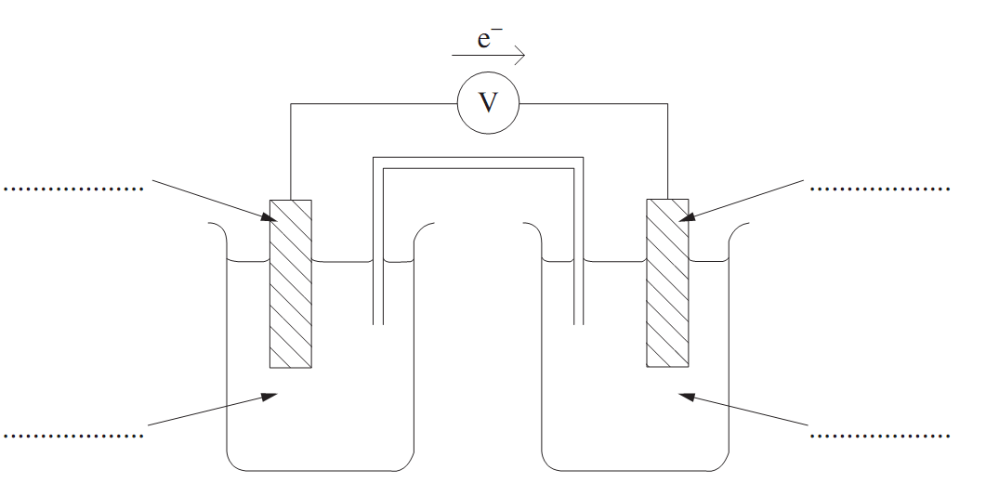**Diagram:**

Zn anode

Zinc nitrate

${KNO}_{3}$ Saltbridge

Cu cathode

Copper (II) nitrate

**Results:**

With the set up above, a voltage of 1.02 V was produced. When the salt bridge was removed, this voltage dropped to 0. Similarly, when the electrodes were swapped, the voltage also dropped to 0.

**Analysis:**

The produced voltage of 1.02 V is smaller than the literature value of 1.10 V. This occurs because this galvanic cell was not set up under the standard conditions at which the standard potentials were measured at. In other words, this galvanic cell did not use 1 ${molL}^{-1}$ electrolyte solutions and was not set up at 25 $℃$ and 100 kPa.

When the salt bridge was removed, the voltage dropped to 0 as the circuit was no longer complete so the migration of ions would have ceased.

When the electrodes were swapped, the voltage also dropped to 0 as the electron transfer will occur at the surface of the electrodes rather than via the external circuit.

Note: The galvanic cell process is destructive testing.

**Discussion:**

Reliability:

This experiment was reliable because when readings for the voltage were compared to other people in the class, the results were similar.

Accuracy:

This experiment was accurate because the apparatus used was properly calibrated and was not faulty.

Validity:

This experiment had a low validity because the voltage produced was 0.08V smaller than the literature value. This was because the galvanic cell was not set up under the standard conditions at which the standard potential were measured at. In order to increase the validity of this experiment, exactly 1 molL-1 electrolyte solutions should have been used.

**Conclusion:**

The conditions in which a galvanic cell is produced was investigated and a voltage of 1.02 V was produced.

P: gather and present information on the structure and chemistry of a dry cell or lead-acid and evaluate it in comparison to silver button cell in terms of chemistry, cost and practicality, impact on society and environmental impacts

**Commerical Galvanic Cells:**

* These are sources of portable DC electricity
* Several galvanic cells can be connected in series to form a battery

**Dry Cells:**

* Non-rechargeable battery
* Max Ecell approximately 1.5V
* 2 types: Leclanche (acid) and alkaline dry cell

**Leclanche Dry Cell**

* Anode – *Zn casing.*
* Cathode – *graphite rod (inert) surrounded by powdered carbon and a moist ${MnO}_{2}$ paste.*
* Electrolyte – *aqueous acidic paste of ${NH}_{4}Cl$ and $ZnCl_{2}$ ( ${NH}_{4}Cl$ is source of H+)*

(oxidation)

$2{{MnO}_{2}}_{(s)}+2{{NH_{4}}^{+}}_{(aq)}+2e^{-}→{{Mn}_{2}O_{3}}_{(s)}+{H_{2}O}_{(l)}+2{NH_{3}}_{(g)}$ (reduction)

${Zn}_{\left(s\right)}+2{{MnO}_{2}}_{(s)}+2{{NH_{4}}^{+}}_{(aq)}→ {{Zn}^{2+}}_{(aq)}+{{Mn}_{2}O_{3}}_{(s)}+{H_{2}O}_{(l)}+2{NH_{3}}_{(g)}$ (overall)

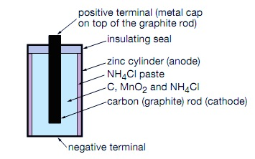

Mnemonic:

**A** **z**ebra **C**ame **g**rabbing **r**eally **p**ink **c**omputer **m**ouse **E**ven **a**t **n**ice **z**ebra **h**ill

Cost and practicality:

|  |  |
| --- | --- |
| **Advantages** | **Disadvantages** |
| * *Cheap* to produce * *Easy to use* and *store* for many *portable* applications * Minimal *environmental*impacts | * *Non-rechargeable* leading to accumulation in landfills over time * Short *working life* since the Zn anode is attacked by acidic $N{H_{4}}^{+}$ and the Zn is oxidised over time so the cell may develop leakage. * *Cannot deliver high currents* since if current is drawn too rapidly, *NH3(g) builds* up causing a *drop in voltage.* * *Low energy density* (big size) |

Impact on Society:

* Had a major impact on society as it was the first commercially produced battery. It allowed the development of many portable devices such as torches, clocks and toys.

Environmental impact

* Relatively low impact since ${Mn}^{3+}$ is readily oxidised into the stable $MnO_{2}$ and the cell components are non-toxic.
* However, Zn is toxic to some species of birds.
* May accumulate in landfills over time since they are discarded after use because they are non-rechargeable.

**Silver button Cell**

Non-rechargeable battery ~ max Ecell of 1.6V

* Anode – *steel cap in contact with powdered Zn.*
* Cathode – *steel case containing powdered ${ Ag}_{2}O$.*
* Electrolyte – *KOH paste.*

${ Zn}_{(s)}+ 2O{H^{-}}_{(aq)}→ {ZnO}_{(s)}+ {H_{2}O}_{(l)}+2e^{-}$ (oxidation)

${{Ag}_{2}O}_{(s)}+{H_{2}O}_{(l)}+2e^{-}→{2Ag}_{(s)}+ 2O{H^{-}}_{(aq)}$ (reduction)

$${ Zn}_{\left(s\right)}+{{Ag}_{2}O}_{(s)}→ {ZnO}_{(s)}+{2Ag}_{(s)}$$

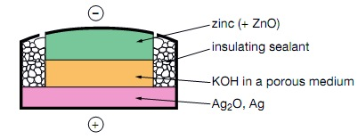

Mnemonic:

**A** **s**ilver **c**at **z**aps **C**ute **s**ilver **c**ases **p**robably **a**t **E**leven in **k**orea.

Cost and practicality:

|  |  |
| --- | --- |
| **Advantages** | **Disadvantages** |
| * Very *small and lightweight*; useful for miniature electronic devices * *High energy density* due to its small size. * Delivers a very *constant voltage* of around 1.6 V * *Long working life.*   *Does not produce toxic wastes* on disposal | * *Non-rechargeable* so must be discarded after use. * Very *expensive* to produce due to the cost of silver so costs more |

Impact on society

* Allowed the development of miniature electronic devices such as watches, pacemakers and calculators.

Environmental impact

* Cell components are non-toxic.
* They may accumulate in landfills over time since they are discarded after use because they are non-rechargeable.

**Comparison:**

|  |  |  |
| --- | --- | --- |
|  | **Leclanche** | **Silver Button Cell** |
| **Chemistry** | Zn anode, carbon and MnO2 cathode, acidic electrolyte | Zn anode, Ag2O cathode, basic electrolyte |
| **Maximum Ecell** |  |  |
| **Uses** | Low-current household electronic devices | Miniature applications |
| **Costs and practicality** | Cheap but short working life | Expensive but longer working life + constant voltage |
| **Environment** | Non-toxic | Zn anode, Ag2O cathode, basic electrolyte |

**Dot Point 4:** Oxidation-reduction reactions are increasing important as a source of energy

SLT: distinguish between stable and radioactive isotopes and describe the conditions under which a nucleus is unstable

**Radioactivity**

* *Radioactivity* ***–*** spontaneous emission of radiation from the decay of an ‘*unstable’* nucleus
* This changes the composition of the nucleus
* *Radioactive isotopes*– atoms with radioactive nuclei
* A radioactive element *emits particles or rays* when they decay into a stable nucleus.
* Three uses of radioisotopes: commercial, medical, industrial
* An isotope is represented by:



Where:

* X = symbol of the element
* A = mass number
* Z = change in temperature (K)
* In a stable nucleus, the nucleons are held together by the *strong nuclear force*which *overcomes* the electrostatic repulsion between protons.
* If the proton numbers increase $→$ number of neutrons must also increase to keep the nucleus stable

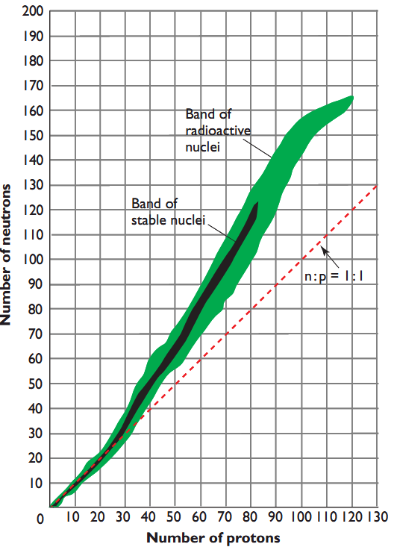**The Conditions for Radioactivity:**

An isotope is radioactive if:

* *Mass of nucleus:*The nucleus is too heavy, $>83$
* *N:P ratio:*Its neutron to proton ratio (n:p) places it outside the zone of stability.

Some Useful Notation:

Proton: ${}_{1}^{1}p$

Neutron: ${}_{0}^{1}n$

Electron: ${}_{-1}^{0}e$

**Types of Radiation and Their Properties**

|  |  |  |  |  |
| --- | --- | --- | --- | --- |
|  | **Identity** | **Penetrating Power** | **Ionising Power** | **Magnetic/electric field** |
| **Alpha (α)** | Helium nucleus: ${}_{2}^{4}{He}$ | Low | High | Deflected |
| **Beta (β)** | Fast moving electron from nucleus: ${}_{-1}^{0}e$ | Moderate | Moderate | Deflected |
| **Gamma (γ)** | EM radiation: ${}_{0}^{0}γ$ | High | Low | Not deflected |

**Alpha Particles:**

* *Alpha particles* are emitted from *heavy unstable nucleus* ( $Z >83)$ to remove a surplus of neutrons and protons.

$${}_{92}^{238}{U→ }{}_{90}^{234}{Th+{}_{2}^{4}{He} }$$

**Beta Particles:**

* *Beta particles* – are a stream of fast-moving electrons ejected from an unstable nucleus
* Ejected from the nucleus when a neutron decays into a proton and electron due high N:P ratio

$${}_{6}^{14}C→ {}_{7}^{14}{N+{}_{-1}^{0}e }$$

**Gamma Rays:**

* *Gamma rays* are high-energy electromagnetic radiation emitted from a *highly energetic nucleus*.
* Often *accompanies* alpha and beta decay

$${}_{43}^{99m}{Tc}→{}_{43}^{99}{Tc+ {}_{0}^{0}γ}$$

Note:’99m’ – the ‘m’ stands for metastable which indicates the excited state

SLT: describe how transuranic elements are produced

**Transuranic Elements**

How are they produced?

* *Lighter transuranic elements* can be formed in *nuclear reactors* by the *neutron bombardment*of a nucleus. The neutrons are derived from *nuclear fission*.
$${}_{92}^{238}U+{}_{0}^{1}{n→}{}_{92}^{239}U→{}_{93}^{239}{Np+}{}_{-1}^{0}e$$

$${}_{93}^{239}{Np→ {}_{94}^{239}{Pu+}}{}_{-1}^{0}e$$

* *Heavier transuranic elements* can be formed in a *particle accelerator* by *charged particle bombardment*.
* The high velocity is required to overcome the electrostatic repulsions between the charged particle and the target nucleus.

$${}_{94}^{239}{Pu+{}_{2}^{4}{He}→}{}_{96}^{242}{Cm+{}_{0}^{1}n}$$

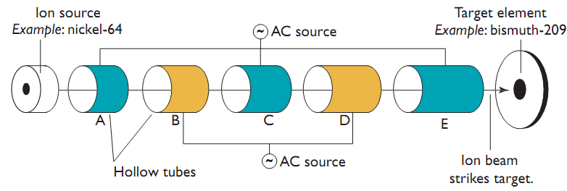

SLT: describe how commercial radioisotopes are produced

**Commercial Radioisotopes:**

* *Radioisotope*- a radioactive isotope of an element.
* Radioisotopes are produced by *nuclear transmutation/transformation* which involves the change of one element into another. A nucleus is bombarded with various particles for this to occur.
* To produce *neutron-rich radioisotopes,* a nucleus is bombarded with neutrons in a *nuclear reactor.*
$${}_{42}^{98}{Mo}+{}_{0}^{1}{n→}{}_{42}^{99}{Mo}→{}_{43}^{99m}{Tc+}{}_{-1}^{0}e$$

* *Neutron-deficient radioisotopes*are produced in a *particle accelerator*by bombarding a nucleus with charged particles.

$${}_{8}^{18}{O+{}_{1}^{1}p→}{}_{9}^{18}{F+{}_{0}^{1}n}$$

Nuclear reactor

Particle Accelerator

SLT: identify instruments and processes that can be used to detect radiation

**Detection of Radiation:**

**Geiger-Muller Counter (Quantitative):**

* A *Geiger-Muller counter*consists of a tube filled with *argon gas* that is connected to a *high voltage supply* and an amplifier/counter.

**Photographic Film (Qualitative):**

* *Darkens upon exposure to radiation*
* Used in *radiation badges (dosimeters)*. This monitors exposure of those who work with radiation on a regular basis

**Scintillation Counter (Quantitative):**

* Certain materials produce a flash of light when struck by ionising radiation
* Amplify with photo multiplier and count electronically

**Cloud Chamber (Qualitative):**

* Cold supersaturated water or alcohol vapour
* Ionising radiation enters and ionises air molecules
* Vapour condenses on the ions forming liquid droplets visible as radiation trail

SLT: identify one use of a named radioisotope in industry and medicine

SLT: describe a way in which the above industrial and medical radioisotopes are used and explain their use in terms in their properties

**Medicine:**

* Usually $β or γ$ emitting radioisotopes with relatively short half-lives (don’t expose patient to high energy radiation for long time)

Half-Life:

* Time required for half of the radioactive nuclei in a sample to undergo decay
* Always constant, unaffected by the initial amount or external conditions
* Half lives for different radioisotopes can vary

**Technetium-99m:**

* *Technetium-99m*is the most widely used isotope for *medical diagnosis*.
* It emits $γ$*radiation* that can be detected outside the body.
$${}_{43}^{99m}{Tc}→{}_{43}^{99}{Tc+ {}_{0}^{0}γ}$$

* Tc-99m has a relatively *short half life of 6 hours*which means the patient’s exposure to radiation will be minimised.
* Produced in the hospital rather than be transported from a nuclear reactor.
* It is prepared by *Mo-99* in a radioisotope generator and can be extracted or ”milked” by flushing a saline solution through it.
* Tc-99m has *many oxidation states* and is thus *reasonably active*so it can be used as a radiopharmaceutical to target certain organs or tissues.
* Can be used to *assess the function of almost every organ in the body*.
* Binds to *tin-based compounds* and when injected into the bloodstream, it attaches to red blood cells.
* Allows for the detection of abnormalities such as *blood clots* and *GI Bleeding*

**Iodine-131:**

* *Iodine-131* is used for the *treatment of thyroid cancers*.
* When it is tagged to NaI and injected into the body, I-131 will accumulate in the thyroid where it undergoes *β decay* to kill cancer cells.
$${}_{53}^{131}I→{}_{54}^{131}{Xe+}{}_{-1}^{0}e$$

* Relatively *short half life of 8 days*which is long enough for treatment to be done but not too long such that the patient is exposed to excess radiation.
* Note: Don’t confuse with Iodine-123 in Medical Physics lol

**Industry:**

**Strontium-90:**

* *Strontium-90*is used in *thickness gauges*to monitor the thickness of sheet materials.
* It emits *low energy β radiation*as follows:
$${}_{38}^{90}{Sr}→{}_{39}^{90}{Y+}{}_{-1}^{0}e$$

* Radiation from theSr-90is passed through the material to a detector. The *intensity of the radiation detected is an indicator of the thickness* of the material.
* *Long half life of 28 years* so it can be used for extended periods of time so no need to keep replacing it

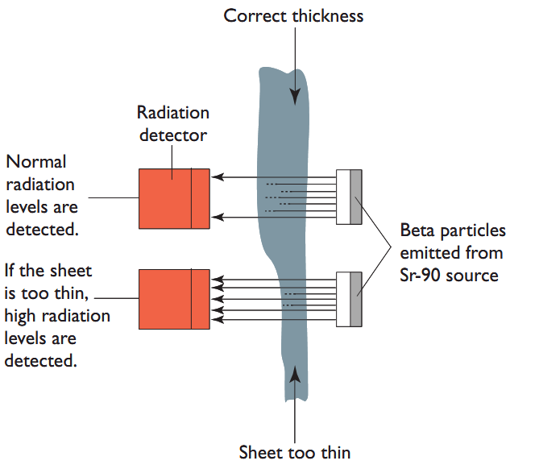Problem:

* Strontium-90 is toxic in the body because it had a tendency to replace calcium. Although it has a similar chemical structure to calcium, when incorporated into the body, it cannot be a substitute for calcium because our body rejects strontium-90.
* When exposed for a long time, it can replace calcium in the bone and this can lead of leukaemia

**Problems with radioisotopes:**

* Ionising radiation is highly damaging
  + Disrupts cellular processes by ionising DNA and proteins forming free radicals/ions
  + May lead to genetic mutations and cancer
* Some can even be incorporated into the body
  + Strontium-90 can replace calcium in the body and may lead to leukaemia
* Dealing with the disposal of radioactive nuclear waste
  + Bury it deep underground so it doesn’t come into contact with us
  + Wearing lead aprons, neck protector for thyroid gland
  + Wear photographic film

P: process information from secondary sources to describe recent discoveries of elements

**Discovery!!!**

* In 1999, a research team in Russia announced the discovery of element 114. The element’s name is flerovium (previously called ununquadium).
* Flerovium was formed by colliding a Ca-48 ion into a Pu-244 target with a particle accelerator.

$${}_{94}^{244}{Pu+{}_{20}^{48}{Ca}→}{}_{114}^{292}{FI}$$